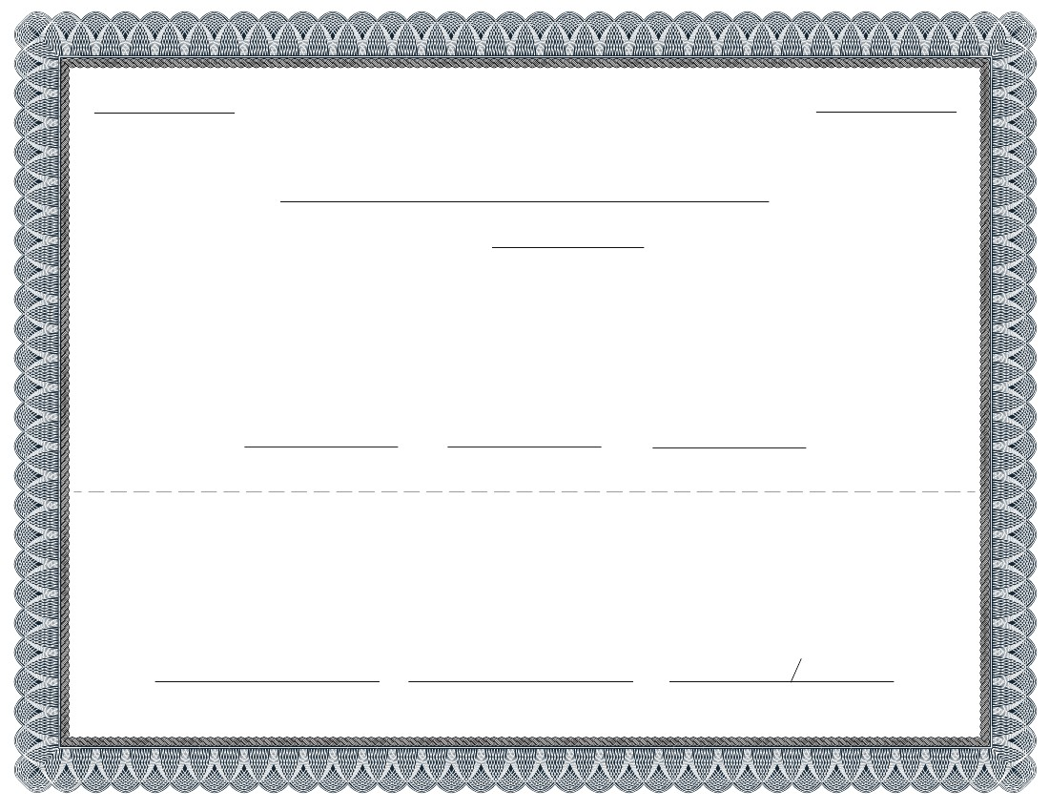

certi cate number

STOCK CERTIFICATE

Corporate Name

number of shares

Incorporated in:,

has a total authorized amount of __________________________ shares, at __________________________ par value.

This is to certify that __________________________ is the owner of ______________shares of_________________ stock

of the above named corporation, which are non-assessable, fully paid shares. The transfer of these shares must be done in

accordance with the by-laws of the named corporation, in person, or by a duly appointed attorney or o cer of the named

corporation, and recorded in the books of the corporation.

President

if sold:

Secretary

Treasurer

For _______________________ received, I, __________________________ sell and transfer _____________ shares, of the _______________shares

represented by this certi cate to

____________________________________________

____________________________________________

____________________________________________

___________________________________________ ,

and appoint ___________________________ the ______________________________, to record this transfer in the corporate books.

Name of shareholder

Signature of shareholder

Signature and name

Witness

http://www.northwestregisteredagent.com