•

and

M&S

between

synergies

Identify

M&S;

NERC and assist NERC’s understanding of the benefits and opportunities of working with

enable broader understanding for M&S of the benefits and opportunities of working with

NERC-funded

Create mutual understanding of the strategy and business needs of both organisations to

scope of this agreement, to:

Under the terms of this memorandum of understanding NERC and M&S seek, within the

**Expectations and Benefits**

**3.**

translate science into innovative tools or solutions for use by M&S;

•

Identify and measure the impact arising from M&S’ collaboration with UK universities

needs;

change in the NERC research community to address M&S (and other stakeholders)

long-term research, translation and training needs with NERC, and encouraging a culture

•

Influence NERC research and postgraduate training investments by articulating M&S’

•

Create opportunities for future joint or allied funding of activities and projects which

activities where they relate to M&S business strategies;

•

training

and

facilities

research,

and

**Purpose**

**1.**

Polaris House, North Star Avenue, Swindon SN2 1EU (hereafter “NERC”).

Of

Natural Environment Research Council

Waterside House, 35 North Wharf Road, London, W2 1NW (hereafter “M&S”)

Of

Marks and Spencer Group plc

This Memorandum of Understanding (MoU) dated XX is made between:

**Strategic Partnership Agreement**

This MoU can be amended only in writing and subject to agreement by both M&S

M&S and the associated strategies and business needs.

The scope of this MoU covers the science and innovation of mutual interest to NERC and

**Scope**

**2.**

and NERC.

•

**MEMORANDUM OF UNDERSTANDING:**

•

This MoU is not legally binding, except as specifically set out below.

practice, as well as identifying strategic research agendas and postgraduate training.

the benefits from our mutual interests in translating areas of existing science into business

The purpose of this MoU is to outline how M&S and NERC will work together to maximise

funding for collaborative projects to translate NERC science into practice,

to M&S.

•

introductions to third parties that can assist in defining and scoping areas of interest

•

evaluating the benefit of collaboration, and

•

identification of opportunities for mutual use of facilities,

•

•

research syntheses to provide the science evidence for M&S decision-makers,

•

people exchange,

research base in areas of interest to M&S,

•

the

explore

licensing arrangements may be entered into as part of any project or programme;

•

Background IP will remain the property of the organisation which owns it, though

with the following basic governing principles:

As part of any collaboration, intellectual property will be handled on a case-by-case basis,

**Intellectual Property and Data**

**6.**

to

and commitment between the Parties, communications, forthcoming opportunities.

agree new activities based on the alignment of strategy and objectives, levels of engagement

areas of interest. The Steering Board will review the collaborative activities in Annex C and

a small number of additional representatives, selected as appropriate, to cover emerging

Translation at NERC), and Jodie Mitchell (Knowledge and Innovation Manager at NERC), with

Sustainable Business at M&S), Sophie Laurie (Associate Director of Innovation and

Membership of the Steering Board will, currently, consist of Carmel McQuaid (Head of

The partnership will be managed through a Steering Board which will meet twice per annum.

**Management of the Partnership**

**5.**

postgraduate

**The Working Relationship**

**4.**

other, when interacting with decision-makers and other stakeholders.

•

Act mutually as advocates for environmental research, the Research Councils, and each

with other organisations where appropriate; and

training activities in priority areas that align with NERC and M&S’ strategies, working

•

Specific activities developed through this working relationship will be detailed in Annex C

and

research,

of

translation

research,

pre-competitive

the

Support

mapping connections and priorities,

clinics

meetings/problem

workshops/networking

as

such

events

portfolio and identification of leading groups in areas of interest to M&S,

•

signposting to academic research and expertise through analysis of the existing NERC

•

and Research Centres enabled through partnership with NERC;

•

sharing and development of relevant strategies,

Activities may include, but are not limited to:

procedures, monitoring and evaluation processes.

financial and resourcing arrangements, timescales, management, impact plan, peer review

be defined in Annex C. This will include the scope of the activity, the type of activity, joint

activities. The implementation, management and control mechanisms for each activity will

that will be appended to this MoU as and when M&S and NERC agree to initiate joint

relationship

Party

any

by

time

any

at

terminated

be

can

following

working

The

from the commencement date.

of this MoU and the working relationship shall remain in force for a period of 36 months

The effective commencement date of this working relationship will be the date of the signing

**Commencement, duration and termination**

The working relationship will not be automatically renewed and will be reviewed before the

**Points of contact**

**10.**

Parties.

whether a renewed working relationship aligns with the strategies and objectives of the

end date with a view to assessing delivery against the objectives set out in this MoU and

**9.**

any unused M&S funds.

terminating Party will honour its share of committed expenditure. NERC will repay to M&S

account if applicable. If applicable, and in accordance with this statement of account, the

the other Party. In such circumstances, NERC will prepare an up to date statement of

the parties and thereafter giving 30 (thirty) calendar days written notice of termination to

consultation period of 30 (thirty) calendar days or such period as agreed otherwise between

a

•

providers is incorporated into a product or service. In these, or related instances, licence

developing the initial data, or where proprietary models are used or data belonging to other

data products are generated, where significant added value may have been invested in

enabling free access to all data generated as part of its funding, there are instances where

of environmental science. Whilst NERC retains an open data policy (http://data.nerc.ac.uk)

Environmental data, models and tools represent a significant component of the exploitation

organisation and M&S to develop opportunities arising from its development.

agreements will be developed with the aim of minimising the costs or complications arising.

Licence conditions for foreground IP would be anticipated to allow the research

account the contribution of M&S to the project or programme;

ownership resides with NERC). This ownership model may be varied to take into

Research Centre (in the case of NERC’s wholly owned Research Centres, the IP

conditions rests with the funded organisation whether this is a university or a

•

The ownership of Foreground IP within the context of NERC’s standard terms and

set out in Annex A.

this MoU.

should protect the NERC brand and its use. Accordingly, the attached Annex B shall apply to

This paragraph is legally binding. NERC require that any Memoranda of Understanding

**Brand Protection**

**8.**

The obligations of NERC under the Act and Regulations and how they apply to this MoU are

Information Act 2000 and the provisions of the Environmental Information Regulations 2004.

This paragraph is legally binding. NERC is subject to the requirements of the Freedom of

**Freedom of Information and Environmental Information Regulations**

**7.**

Signed for and on behalf of NERC by:

__

**Date**

**Title**

________________

**Name**

__

**Date**

Chief Executive

**Title**

Professor Duncan Wingham

**Name**

Telephone

35 North Wharf Road

Waterside House

M&S:

jodark@nerc.ac.uk

Email

01793 418004

London

Jodie Mitchell

Attention

Swindon SN2 1EU

North Star Avenue

Polaris House

NERC:

Signed for and on behalf of M&S by:

**Signatures**

**11.**

Carmel.Mcquaid@marks-and-spencer.com

Email

020 7935 4422

Telephone

Carmel McQuaid

Attention

W2 1NW

This Agreement:

be applicable to the information or justify a request refusal. In the application of certain

exemptions NERC is obliged to undertake a Public Interest Test prior to making a final

decision on its response to the request.

Compliance with the Act requires NERC to respond as quickly as possible, but no later than

20 working days, from receipt of the request.

A requester may challenge the information provided or the exemptions applied by

requesting an internal review and appeal to the ICO if they are not satisfied by the outcome

of the internal review. After consideration the ICO will issue a Decision Notice to which NERC

would be obliged to comply.

identify any sensitivity associated with the information and whether any exemptions might

In the event that NERC receives an FOI or EIR request that relates to this agreement NERC

will:

i)

Notify the signatory to this agreement of the request as soon as practicable after

receipt of the request;

Environmental Information Regulations (2004)* which requires them to make available, on

**THE NATURAL ENVIRONMENT RESEARCH COUNCIL**

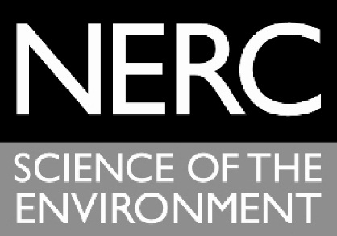

**Openness and Transparency:**

**FREEDOM OF INFORMATION**

As a UK Public Authority the Natural Environment Research Council is obligated to comply

with the requirements of the Freedom of Information Act (FOIA) 2000 (Schedule 1: Public

Authorities: Part VI: Other Public Bodies and Offices: General), and the provisions of the

**ANNEX A**

request, environmental information held and not necessarily published in the normal course

of its public responsibilities.

The FOIA gives individuals the right to seek information from a public authority and where

held to have that information made available to them. The Authority has the right, under

certain circumstances, to withhold information through the application of exemptions laid

out in the Act and in line with guidance provided by the Information Commissioners Office

(ICO).

On receipt of a request for information NERC will ascertain whether that information is held,

approach to the handling the request.

Ensure that NERC is able to meet its response time obligations.

*Compliance with the Environmental Information Regulations also refers to the Code of

Practice on the discharge of the obligations of public authorities under the Environmental

Information Regulations 2004 (SI 2004 No. 3391). Issued under Regulation 16 of the

Regulations, February 2005.

**Other Information Access Regimes:**

In the event that the request covers more than one information access regime (EIR/FOIA or

Data Protection Act) the parties to the Agreement will discuss and agree an appropriate

viii)

v)

ii)

Work in conjunction with the signatory to identify information held relevant to the

request;

iii)

Work in conjunction with the signatory to agree any sensitivity associated with the

information requested;

iv)

Advise the signatory of any exemptions applied to the response to the request;

Notify the signatory of any subsequent appeal to the response.

Signatories to the agreement will:

vi)

Co-operate with NERC over the consideration of the request;

vii)

Make available information when requested;

Application

EU

EU012313573

9, 16,

14/11/201

41,42

3

Published

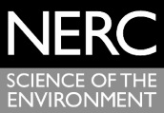

Published

2.3 M&S acknowledges that the Trade Marks are the property of NERC and shall indicate

Commercial Contracts Manager for express written approval at least fourteen (14)

days prior to any such material being used or published.

2.2 M&S shall only use the Trade Marks as directed from time to time by NERC in writing

and shall observe any instructions given by NERC (including as to colours and size of

representations), and shall not use the Trade Marks in any way which would tend to

allow them to become generic, lose their distinctiveness, become liable to mislead

the public, or be materially detrimental to or inconsistent with the good name,

goodwill, reputation and image of NERC.

containing the Trade Marks to be used in relation to the Agreement to the NERC

that the Trade Marks are the property of NERC by accompanying the use of the Trade

Marks with wording and clear marking of the TM sign in the case of unregistered

marks and the

sign in the case of the Registered Marks.



3

**2. Use of the Trademarks**

2.1 M&S shall not be entitled to use the Trade Marks for any purpose or in any medium or

form without the prior written approval of NERC. M&S shall submit any material

**Territory**

**Trade**

**Registration**

**THE NATURAL ENVIRONMENT RESEARCH COUNCIL**

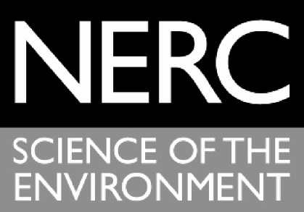

**Brand Protection**

**1. Definitions**

"Trade Marks" means the trade marks (whether unregistered or the Registered

Marks) of NERC;

"Registered Marks" means the following Trade Marks:

**Class**

EU

NERC

EU012313193

9, 16,

14/11/201

Application

41,42

**ANNEX B**

**filing**

**number**

**Marks**

**Status**

**Date of**

2.6 M&S shall not at any time, whether during or after termination of this Agreement, use

as specifically set out in this Agreement and agrees that the benefit of all such use shall

accrue to NERC. If any goodwill or other rights accrue to M&S, M&S shall hold all such

goodwill and other rights on trust for NERC and shall execute such assignments of such

goodwill and other rights to NERC (or its nominee) as NERC may direct.

2.5 M&S shall not adopt or use any trade marks, symbol or device which incorporates or

is confusingly similar to, the Trade Marks. M&S shall not at any time, whether during

or after termination of this Agreement, apply anywhere in the world to register any

trade marks identical to or resembling the Trade Marks.

2.4 M&S shall not obtain or claim any right; title or interest in or to the Trade Marks except

the Trade Marks as part of any corporate business or trading name or style of M&S.

that all collaborative activities will draw upon one or more of these thematic areas, which

fall under an overarching objective of providing food supply chains with robust decision-

support tools.

i)

Applying an ecosystem services approach to land use

The ecosystem in which agriculture takes place provides many services in addition to food

production, such as water and flood regulation, carbon capture and recreation. There is a

need for agriculture and food retail businesses to fully understand their impacts on

ecosystem services (benefits and dis-benefits), and to be informed of the best way to

measure and quantify those services and manage trade-offs. M&S wish to integrate the

Section 2 outlines the thematic areas of mutual interest to NERC and M&S. It is expected

principles of an ecosystems approach in order to promote improved decision-making within

their supply chains.

ii)

Water risk in global food supply chains

Climate change and population growth are expected to put significant pressure on water

resources, particularly in sub-Saharan Africa and parts of Asia. Businesses, including M&S,

are becoming increasingly concerned about water risks in their operations and supply chains,

and are starting to take action to address those risks. Insufficient data on water is limiting

contribute to the identification of priorities for new strategic research.

**Year 1 Partnership Plan**

**1.**

**Introduction**

th

This Partnership Plan underpins the agreement signed on 17

December 2015 between the

Natural Environment Research Council (NERC) and Marks and Spencer (M&S) to work

strategically together.

NERC and M&S have agreed to work together in a long-term relationship to understand

specific business strategies, interests and needs more deeply; to accelerate and deliver

impact by translating existing science into real-world applications and solutions; and, to

**ANNEX C**

The Partnership Plan guides the investment and commitment of both NERC and M&S on an

annual basis. It outlines a planned programme of activity driven by the needs, issues and

challenges agreed by the Partnership Steering Board.

The Partnership Plan sets out the activities that will be delivered in the year commencing

2016, the expected timescales for this and any financial or other contribution from both

NERC and M&S.

The Steering Board will review the collaborative activities and agree new activities based on

the alignment of strategy and objectives, levels of engagement and commitment between

the Parties, communications, and forthcoming opportunities.

**2.**

**Thematic Areas**

innovation mechanism. Using existing mechanisms means that a) resources can be managed

further development of aquaculture, and; identify risks to current activities.

Illegal and unreported (IUU) fishing worldwide accounts for up to 26 million metric tonnes of

fish annually, worth up to $23.5 billion. Fishing in this manner prevents sustainable

management of stock levels and can lead to fishery collapse. Live satellite tracking data can

monitor fishing vessels, and alert officials to any suspicious movements; thereby protecting

marine ecosystems and the livelihoods of fishing communities.

**Strategic Partnership Activities**

NERC strategic partnerships invest in any form of existing NERC people exchange or

most efficiently located from an environmental perspective; identify potential areas for

efficiently through planned call processes; and, b) mechanisms are recognised by the

academic community.

Section 4 describes in detail the activities that will be delivered through the Partnership in

the coming year. However, the diagram below shows a broad overview of the types of

activities that will be considered for funding under the partnership.

the ability of businesses to take well-informed decisions on appropriate mitigation options

(SST), ocean fronts. These data could be used to: evaluate whether current activities are

chlorophyll concentration, presence of harmful algal blooms (HAB), sea surface temperature

temporal and spatial information of a variety of parameters including: water quality,

environment and its interactions with fish farms. Earth observation data can provide critical

Sustainable expansion of the industry requires improved understanding of the natural

By 2030, 62% of fish eaten by humans is expected to be produced from aquaculture.

Satellite data for sustainable aquaculture and fisheries

iii)

catchment and policy level.

deliver practical tools for businesses and NGOs to design interventions at the field,

satellite-based remotely sensed data which offer significant potential for filling data gaps; 3)

through combining data from a range of sources; 2) understand novel techniques using

understand the water resource context within which businesses or their supply chains sit

once water risk hot-spots have been identified. In order to address this, there is a need to 1)

1

Develop best practice guidance for businesses on how to integrate Natural

applicable to agriculture and food retail sectors.

•

Develop a synthesis report of the existing Natural Capital Accounting tools

**What**

.

ecosystem services and trade-offs will be central to this project

•

order to sustainably manage their agricultural land. A consideration of

funded research outputs that food retailers such as M&S can draw upon in

•

An innovation internship which will develop a systematic review of NERC-

**Purpose**

maintained for grouse production and would provide a suitable case study site for this innovation internship.

Heritage, Game & Wildlife Conservation Trust, RSPB and Natural England. The Langholm Moor is currently

The Langholm Moor Demonstration Project is a partnership between Buccleuch Estates, Scottish Natural

1

Capital Accounting into their reporting.

**Translation-focused**: primarily, activities will focus on translation of existing research

to the whole academic community and not favouring any particular institution.

**Openness**: any funding will be allocated to projects through open competition accessible

4.

and allow the partnership to capture impact ‘stories’ from engagement

**Impact driven**: partnerships will be focused to deliver on the impact agenda for NERC

3.

**3.**

2.

**Strategic**: activities funded will clearly meet strategic interests of both partners

1.

principles for Strategic Partnerships with NERC:

The use of each of the above outlined mechanisms will be guided by the four overarching

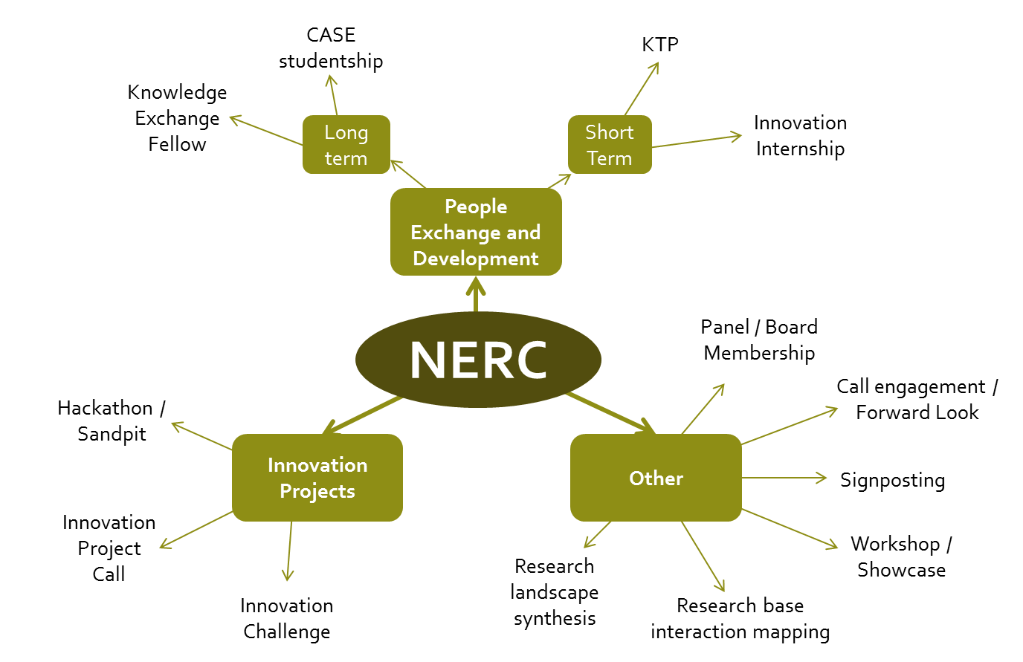

**Innovation Internship: Applying an ecosystems approach to land use**

has been chosen and how it will be managed, monitored and evaluated.

This section describes collaborative activities in detail, including the type of activity, why it

**Year 1 activities and outputs**

**Monitoring and**

Jodie Mitchell and Mark Oddy to lead.

•

Project partners.

Ex-post evaluation

•

**Evaluation**

Monitoring continuous through duration by Jodie Mitchell and Mark Oddy.

•

Internship will be funded financially by NERC from strategic partnership

•

funds (up to £50k).

**How much**

M&S/ Langholm Moor Demonstration Project will provide an in-kind

•

contribution.

Call development between NERC, M&S and Langholm Moor Demonstration

•

**Management**

effectively combined and used by businesses and NGOs to deliver mitigation

strategies for water risk in global supply chains.

To bring together businesses, NGOs and academics to discuss the issue of

•

**What**

water risk and how, collectively, it could be managed.

To identify potential future activities, partnerships and collaborations that

•

could address water risk in global supply chains.

**Output/outcome**

•

Workshop report and recommendations of next steps.

•

**Workshop – Water Risk to Global Food Supply Chains**

**Purpose and objectives**

To gain an understanding of the existing research and data that could be

There is a need for agriculture and retail businesses to understand their

Provision of best practice guidance on Natural Capital Accounting for the

•

agriculture and food retail sectors.

•

impacts on ecosystem services (benefits and dis-benefits), and to be

informed of the best way to measure and quantify those services and

manage trade-offs.

**Why**

This activity would build on and apply strategic NERC-funded research, data

•

and expertise including: the Valuing Nature Network, the Biodiversity and

Ecosystems Services research programme, Rural Economy and Land Use

To gain a deeper understanding of sustainable grouse moor management

**Objectives**

research programme.

•

using existing NERC science.

To measure and quantify the ecosystem services provided by grouse

•

moorland, and to identify and manage trade-offs.

**Outputs/outcomes**

Provision of information on NERC-funded grants of relevance to M&S and

•

the Langholm Moor Demostration project.

Competition will be by Expression of Interest (EOI) and invitation to submit

Open competition to NERC community.

•

•

•

**How**

full proposal through JeS.

Duration: EOI live for 6 weeks; applicants submit full proposal; invite to

•

interview (interviewed by Steering Board plus Langholm); award grant.

Inform future innovation projects with M&S.

•

Announcement of Opportunity development: from November 2016

•

Call live: Winter 2015

•

**When**

1 x 6 month internship

•

Start March 2016 – end August 2016

Exchange Workshop

Water Risk Workshop

Innovation Partner

Activity 'live'

Preparatory activity

Steering Board

etc.

(WWF) to develop workshop aims and objectives, agenda, list of invitees,

**Monitoring and**

Ex-post evaluation (internal, informal)

•

**Evaluation**

**Management**

•

Jodie Mitchell (NERC), Simon Reid (M&S), Conor Linstead and Dave Tickner

•

M&S to provide venue

**2016**

**Activity**

**How much**

allocation of resources and forecasting expenditure over the course of the year.

commissioning and implementation stages. This timetable is intended to aid Parties in the

Section 5 provides a timetable for the full duration of activities, including the planning,

**Partnership Plan 2015/16**

**4.**

innovation projects call.

•

To develop future ideas for Strategic Partnership activities, such as an

work.

**Why**

•

Link to RCUK Global Food Security programme and UK Water Partnership

•

To build on M&S’ water risk-mapping work in collaboration with WWF.

•

Strategic fit to NERC, M&S and WWF interests.

•

NERC to fund up to £10k

usual communication channels.

**How**

•

One-off event promoted to NERC academics and relevant end-users via

•

Workshop: April 2016

**When**

•

Workshop development: from November 2015

Nov

Innovation Internship

Aug

Apr

Sep

Oct

May

Mar

Dec

Feb

Jun

Jan

Jul