MEMORANDUM OF UNDERSTANDING:
Strategic Partnership Agreement
This Memorandum of Understanding (MoU) dated XX is made between:
Marks and Spencer Group plc
Of
Waterside House, 35 North Wharf Road, London, W2 1NW (hereafter “M&S”)
and
Natural Environment Research Council
Of
Polaris House, North Star Avenue, Swindon SN2 1EU (hereafter “NERC”).
1.
Purpose
The purpose of this MoU is to outline how M&S and NERC will work together to maximise
the benefits from our mutual interests in translating areas of existing science into business
practice, as well as identifying strategic research agendas and postgraduate training.
•
This MoU is not legally binding, except as specifically set out below.
•
This MoU can be amended only in writing and subject to agreement by both M&S
and NERC.
2.
Scope
The scope of this MoU covers the science and innovation of mutual interest to NERC and
M&S and the associated strategies and business needs.
3.
Expectations and Benefits
Under the terms of this memorandum of understanding NERC and M&S seek, within the
scope of this agreement, to:
•
Create mutual understanding of the strategy and business needs of both organisations to
enable broader understanding for M&S of the benefits and opportunities of working with
NERC and assist NERC’s understanding of the benefits and opportunities of working with
M&S;
•
Identify
synergies
between
M&S
and
NERC-funded
research,
facilities
and
training
activities where they relate to M&S business strategies;
•
Create opportunities for future joint or allied funding of activities and projects which
translate science into innovative tools or solutions for use by M&S;
•
Influence NERC research and postgraduate training investments by articulating M&S’
long-term research, translation and training needs with NERC, and encouraging a culture
change in the NERC research community to address M&S (and other stakeholders)
needs;
•
Identify and measure the impact arising from M&S’ collaboration with UK universities
and Research Centres enabled through partnership with NERC;
•
Support
the
pre-competitive
research,
translation
of
research,
and
postgraduate
training activities in priority areas that align with NERC and M&S’ strategies, working
with other organisations where appropriate; and
•
Act mutually as advocates for environmental research, the Research Councils, and each
other, when interacting with decision-makers and other stakeholders.
4.
The Working Relationship
Specific activities developed through this working relationship will be detailed in Annex C
that will be appended to this MoU as and when M&S and NERC agree to initiate joint
activities. The implementation, management and control mechanisms for each activity will
be defined in Annex C. This will include the scope of the activity, the type of activity, joint
financial and resourcing arrangements, timescales, management, impact plan, peer review
procedures, monitoring and evaluation processes.
Activities may include, but are not limited to:
•
sharing and development of relevant strategies,
•
mapping connections and priorities,
•
signposting to academic research and expertise through analysis of the existing NERC
portfolio and identification of leading groups in areas of interest to M&S,
•
events
such
as
workshops/networking
meetings/problem
clinics
to
explore
the
research base in areas of interest to M&S,
•
people exchange,
•
research syntheses to provide the science evidence for M&S decision-makers,
•
funding for collaborative projects to translate NERC science into practice,
•
identification of opportunities for mutual use of facilities,
•
evaluating the benefit of collaboration, and
•
introductions to third parties that can assist in defining and scoping areas of interest
to M&S.
5.
Management of the Partnership
The partnership will be managed through a Steering Board which will meet twice per annum.
Membership of the Steering Board will, currently, consist of Carmel McQuaid (Head of
Sustainable Business at M&S), Sophie Laurie (Associate Director of Innovation and
Translation at NERC), and Jodie Mitchell (Knowledge and Innovation Manager at NERC), with
a small number of additional representatives, selected as appropriate, to cover emerging
areas of interest. The Steering Board will review the collaborative activities in Annex C and
agree new activities based on the alignment of strategy and objectives, levels of engagement
and commitment between the Parties, communications, forthcoming opportunities.
6.
Intellectual Property and Data
As part of any collaboration, intellectual property will be handled on a case-by-case basis,
with the following basic governing principles:
•
Background IP will remain the property of the organisation which owns it, though
licensing arrangements may be entered into as part of any project or programme;
•
The ownership of Foreground IP within the context of NERC’s standard terms and
conditions rests with the funded organisation whether this is a university or a
Research Centre (in the case of NERC’s wholly owned Research Centres, the IP
ownership resides with NERC). This ownership model may be varied to take into
account the contribution of M&S to the project or programme;
•
Licence conditions for foreground IP would be anticipated to allow the research
organisation and M&S to develop opportunities arising from its development.
Environmental data, models and tools represent a significant component of the exploitation
of environmental science. Whilst NERC retains an open data policy (http://data.nerc.ac.uk)
enabling free access to all data generated as part of its funding, there are instances where
data products are generated, where significant added value may have been invested in
developing the initial data, or where proprietary models are used or data belonging to other
providers is incorporated into a product or service. In these, or related instances, licence
agreements will be developed with the aim of minimising the costs or complications arising.
7.
Freedom of Information and Environmental Information Regulations
This paragraph is legally binding. NERC is subject to the requirements of the Freedom of
Information Act 2000 and the provisions of the Environmental Information Regulations 2004.
The obligations of NERC under the Act and Regulations and how they apply to this MoU are
set out in Annex A.
8.
Brand Protection
This paragraph is legally binding. NERC require that any Memoranda of Understanding
should protect the NERC brand and its use. Accordingly, the attached Annex B shall apply to
this MoU.
9.
Commencement, duration and termination
The effective commencement date of this working relationship will be the date of the signing
of this MoU and the working relationship shall remain in force for a period of 36 months
from the commencement date.
The
working
relationship
can
be
terminated
at
any
time
by
any
Party
following
a
consultation period of 30 (thirty) calendar days or such period as agreed otherwise between
the parties and thereafter giving 30 (thirty) calendar days written notice of termination to
the other Party. In such circumstances, NERC will prepare an up to date statement of
account if applicable. If applicable, and in accordance with this statement of account, the
terminating Party will honour its share of committed expenditure. NERC will repay to M&S
any unused M&S funds.
The working relationship will not be automatically renewed and will be reviewed before the
end date with a view to assessing delivery against the objectives set out in this MoU and
whether a renewed working relationship aligns with the strategies and objectives of the
Parties.
10.
Points of contact
NERC:
Polaris House
North Star Avenue
Swindon SN2 1EU
Attention
Jodie Mitchell
Telephone
01793 418004
Email
jodark@nerc.ac.uk
M&S:
Waterside House
35 North Wharf Road
London
W2 1NW
Attention
Carmel McQuaid
Telephone
020 7935 4422
Email
Carmel.Mcquaid@marks-and-spencer.com
11.
Signatures
Signed for and on behalf of M&S by:
Name
Title
Date
__
Signed for and on behalf of NERC by:
Name
Professor Duncan Wingham
Title
Chief Executive
Date
__
________________
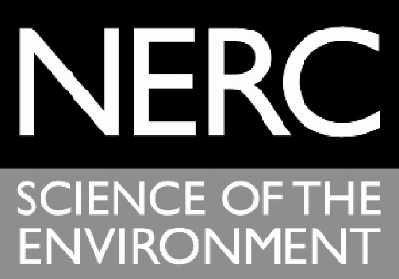
ANNEX A
THE NATURAL ENVIRONMENT RESEARCH COUNCIL
Openness and Transparency:
FREEDOM OF INFORMATION
As a UK Public Authority the Natural Environment Research Council is obligated to comply
with the requirements of the Freedom of Information Act (FOIA) 2000 (Schedule 1: Public
Authorities: Part VI: Other Public Bodies and Offices: General), and the provisions of the
Environmental Information Regulations (2004)* which requires them to make available, on
request, environmental information held and not necessarily published in the normal course
of its public responsibilities.
The FOIA gives individuals the right to seek information from a public authority and where
held to have that information made available to them. The Authority has the right, under
certain circumstances, to withhold information through the application of exemptions laid
out in the Act and in line with guidance provided by the Information Commissioners Office
(ICO).
On receipt of a request for information NERC will ascertain whether that information is held,
identify any sensitivity associated with the information and whether any exemptions might
be applicable to the information or justify a request refusal. In the application of certain
exemptions NERC is obliged to undertake a Public Interest Test prior to making a final
decision on its response to the request.
Compliance with the Act requires NERC to respond as quickly as possible, but no later than
20 working days, from receipt of the request.
A requester may challenge the information provided or the exemptions applied by
requesting an internal review and appeal to the ICO if they are not satisfied by the outcome
of the internal review. After consideration the ICO will issue a Decision Notice to which NERC
would be obliged to comply.
This Agreement:
In the event that NERC receives an FOI or EIR request that relates to this agreement NERC
will:
i)
Notify the signatory to this agreement of the request as soon as practicable after
receipt of the request;
ii)
Work in conjunction with the signatory to identify information held relevant to the
request;
iii)
Work in conjunction with the signatory to agree any sensitivity associated with the
information requested;
iv)
Advise the signatory of any exemptions applied to the response to the request;
v)
Notify the signatory of any subsequent appeal to the response.
Signatories to the agreement will:
vi)
Co-operate with NERC over the consideration of the request;
vii)
Make available information when requested;
viii)
Ensure that NERC is able to meet its response time obligations.
*Compliance with the Environmental Information Regulations also refers to the Code of
Practice on the discharge of the obligations of public authorities under the Environmental
Information Regulations 2004 (SI 2004 No. 3391). Issued under Regulation 16 of the
Regulations, February 2005.
Other Information Access Regimes:
In the event that the request covers more than one information access regime (EIR/FOIA or
Data Protection Act) the parties to the Agreement will discuss and agree an appropriate
approach to the handling the request.
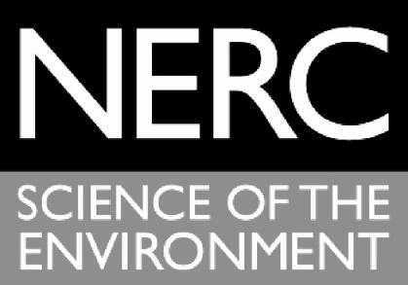
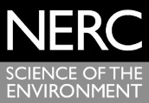
ANNEX B
THE NATURAL ENVIRONMENT RESEARCH COUNCIL
Brand Protection
1. Definitions
"Trade Marks" means the trade marks (whether unregistered or the Registered
Marks) of NERC;
"Registered Marks" means the following Trade Marks:
Territory
Trade
Marks
Registration
number
Class
Date of
filing
Status
EU
NERC
EU012313193
9, 16,
41,42
14/11/201
3
Application
Published
EU
EU012313573
9, 16,
41,42
14/11/201
3
Application
Published
2. Use of the Trademarks
2.1 M&S shall not be entitled to use the Trade Marks for any purpose or in any medium or
form without the prior written approval of NERC. M&S shall submit any material
containing the Trade Marks to be used in relation to the Agreement to the NERC
Commercial Contracts Manager for express written approval at least fourteen (14)
days prior to any such material being used or published.
2.2 M&S shall only use the Trade Marks as directed from time to time by NERC in writing
and shall observe any instructions given by NERC (including as to colours and size of
representations), and shall not use the Trade Marks in any way which would tend to
allow them to become generic, lose their distinctiveness, become liable to mislead
the public, or be materially detrimental to or inconsistent with the good name,
goodwill, reputation and image of NERC.
2.3 M&S acknowledges that the Trade Marks are the property of NERC and shall indicate
that the Trade Marks are the property of NERC by accompanying the use of the Trade
Marks with wording and clear marking of the TM sign in the case of unregistered
marks and the

sign in the case of the Registered Marks.
2.4 M&S shall not obtain or claim any right; title or interest in or to the Trade Marks except
as specifically set out in this Agreement and agrees that the benefit of all such use shall
accrue to NERC. If any goodwill or other rights accrue to M&S, M&S shall hold all such
goodwill and other rights on trust for NERC and shall execute such assignments of such
goodwill and other rights to NERC (or its nominee) as NERC may direct.
2.5 M&S shall not adopt or use any trade marks, symbol or device which incorporates or
is confusingly similar to, the Trade Marks. M&S shall not at any time, whether during
or after termination of this Agreement, apply anywhere in the world to register any
trade marks identical to or resembling the Trade Marks.
2.6 M&S shall not at any time, whether during or after termination of this Agreement, use
the Trade Marks as part of any corporate business or trading name or style of M&S.
ANNEX C
Year 1 Partnership Plan
1.
Introduction
This Partnership Plan underpins the agreement signed on 17
th
December 2015 between the
Natural Environment Research Council (NERC) and Marks and Spencer (M&S) to work
strategically together.
NERC and M&S have agreed to work together in a long-term relationship to understand
specific business strategies, interests and needs more deeply; to accelerate and deliver
impact by translating existing science into real-world applications and solutions; and, to
contribute to the identification of priorities for new strategic research.
The Partnership Plan guides the investment and commitment of both NERC and M&S on an
annual basis. It outlines a planned programme of activity driven by the needs, issues and
challenges agreed by the Partnership Steering Board.
The Partnership Plan sets out the activities that will be delivered in the year commencing
2016, the expected timescales for this and any financial or other contribution from both
NERC and M&S.
The Steering Board will review the collaborative activities and agree new activities based on
the alignment of strategy and objectives, levels of engagement and commitment between
the Parties, communications, and forthcoming opportunities.
2.
Thematic Areas
Section 2 outlines the thematic areas of mutual interest to NERC and M&S. It is expected
that all collaborative activities will draw upon one or more of these thematic areas, which
fall under an overarching objective of providing food supply chains with robust decision-
support tools.
i)
Applying an ecosystem services approach to land use
The ecosystem in which agriculture takes place provides many services in addition to food
production, such as water and flood regulation, carbon capture and recreation. There is a
need for agriculture and food retail businesses to fully understand their impacts on
ecosystem services (benefits and dis-benefits), and to be informed of the best way to
measure and quantify those services and manage trade-offs. M&S wish to integrate the
principles of an ecosystems approach in order to promote improved decision-making within
their supply chains.
ii)
Water risk in global food supply chains
Climate change and population growth are expected to put significant pressure on water
resources, particularly in sub-Saharan Africa and parts of Asia. Businesses, including M&S,
are becoming increasingly concerned about water risks in their operations and supply chains,
and are starting to take action to address those risks. Insufficient data on water is limiting
the ability of businesses to take well-informed decisions on appropriate mitigation options
once water risk hot-spots have been identified. In order to address this, there is a need to 1)
understand the water resource context within which businesses or their supply chains sit
through combining data from a range of sources; 2) understand novel techniques using
satellite-based remotely sensed data which offer significant potential for filling data gaps; 3)
deliver practical tools for businesses and NGOs to design interventions at the field,
catchment and policy level.
iii)
Satellite data for sustainable aquaculture and fisheries
By 2030, 62% of fish eaten by humans is expected to be produced from aquaculture.
Sustainable expansion of the industry requires improved understanding of the natural
environment and its interactions with fish farms. Earth observation data can provide critical
temporal and spatial information of a variety of parameters including: water quality,
chlorophyll concentration, presence of harmful algal blooms (HAB), sea surface temperature
(SST), ocean fronts. These data could be used to: evaluate whether current activities are
most efficiently located from an environmental perspective; identify potential areas for
further development of aquaculture, and; identify risks to current activities.
Illegal and unreported (IUU) fishing worldwide accounts for up to 26 million metric tonnes of
fish annually, worth up to $23.5 billion. Fishing in this manner prevents sustainable
management of stock levels and can lead to fishery collapse. Live satellite tracking data can
monitor fishing vessels, and alert officials to any suspicious movements; thereby protecting
marine ecosystems and the livelihoods of fishing communities.
Strategic Partnership Activities
NERC strategic partnerships invest in any form of existing NERC people exchange or
innovation mechanism. Using existing mechanisms means that a) resources can be managed
efficiently through planned call processes; and, b) mechanisms are recognised by the
academic community.
Section 4 describes in detail the activities that will be delivered through the Partnership in
the coming year. However, the diagram below shows a broad overview of the types of
activities that will be considered for funding under the partnership.
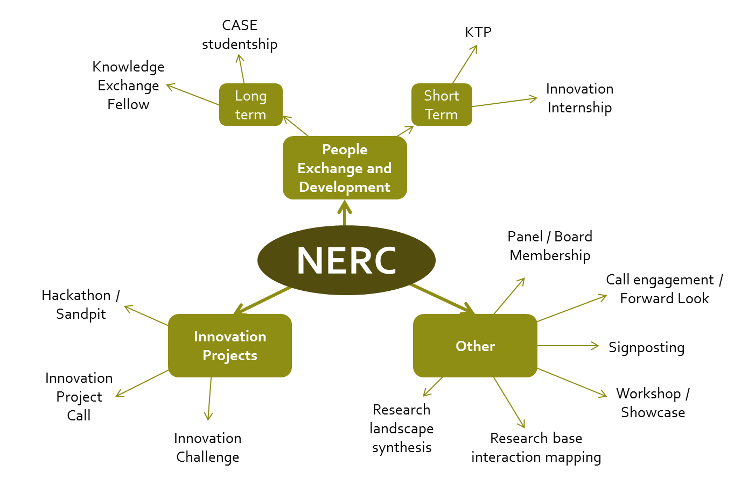
The use of each of the above outlined mechanisms will be guided by the four overarching
principles for Strategic Partnerships with NERC:
1.
Strategic: activities funded will clearly meet strategic interests of both partners
2.
Translation-focused: primarily, activities will focus on translation of existing research
3.
Impact driven: partnerships will be focused to deliver on the impact agenda for NERC
and allow the partnership to capture impact ‘stories’ from engagement
4.
Openness: any funding will be allocated to projects through open competition accessible
to the whole academic community and not favouring any particular institution.
3.
Year 1 activities and outputs
This section describes collaborative activities in detail, including the type of activity, why it
has been chosen and how it will be managed, monitored and evaluated.
Innovation Internship: Applying an ecosystems approach to land use
What
Purpose
•
An innovation internship which will develop a systematic review of NERC-
funded research outputs that food retailers such as M&S can draw upon in
order to sustainably manage their agricultural land. A consideration of
ecosystem services and trade-offs will be central to this project
1
.
•
Develop a synthesis report of the existing Natural Capital Accounting tools
applicable to agriculture and food retail sectors.
•
Develop best practice guidance for businesses on how to integrate Natural
Capital Accounting into their reporting.
1
The Langholm Moor Demonstration Project is a partnership between Buccleuch Estates, Scottish Natural
Heritage, Game & Wildlife Conservation Trust, RSPB and Natural England. The Langholm Moor is currently
maintained for grouse production and would provide a suitable case study site for this innovation internship.
Objectives
•
To gain a deeper understanding of sustainable grouse moor management
using existing NERC science.
•
To measure and quantify the ecosystem services provided by grouse
moorland, and to identify and manage trade-offs.
Outputs/outcomes
•
Provision of information on NERC-funded grants of relevance to M&S and
the Langholm Moor Demostration project.
•
Provision of best practice guidance on Natural Capital Accounting for the
agriculture and food retail sectors.
Why
•
There is a need for agriculture and retail businesses to understand their
impacts on ecosystem services (benefits and dis-benefits), and to be
informed of the best way to measure and quantify those services and
manage trade-offs.
•
This activity would build on and apply strategic NERC-funded research, data
and expertise including: the Valuing Nature Network, the Biodiversity and
Ecosystems Services research programme, Rural Economy and Land Use
research programme.
•
Inform future innovation projects with M&S.
When
•
Announcement of Opportunity development: from November 2016
•
Call live: Winter 2015
•
1 x 6 month internship
•
Start March 2016 – end August 2016
How
•
Open competition to NERC community.
•
Competition will be by Expression of Interest (EOI) and invitation to submit
full proposal through JeS.
•
Duration: EOI live for 6 weeks; applicants submit full proposal; invite to
interview (interviewed by Steering Board plus Langholm); award grant.
How much
•
Internship will be funded financially by NERC from strategic partnership
funds (up to £50k).
•
M&S/ Langholm Moor Demonstration Project will provide an in-kind
contribution.
Management
•
Call development between NERC, M&S and Langholm Moor Demonstration
Project partners.
•
Jodie Mitchell and Mark Oddy to lead.
Monitoring and
Evaluation
•
Ex-post evaluation
•
Monitoring continuous through duration by Jodie Mitchell and Mark Oddy.
Workshop – Water Risk to Global Food Supply Chains
What
Purpose and objectives
•
To gain an understanding of the existing research and data that could be
effectively combined and used by businesses and NGOs to deliver mitigation
strategies for water risk in global supply chains.
•
To bring together businesses, NGOs and academics to discuss the issue of
water risk and how, collectively, it could be managed.
•
To identify potential future activities, partnerships and collaborations that
could address water risk in global supply chains.
Output/outcome
•
Workshop report and recommendations of next steps.
Why
•
Strategic fit to NERC, M&S and WWF interests.
•
To build on M&S’ water risk-mapping work in collaboration with WWF.
•
Link to RCUK Global Food Security programme and UK Water Partnership
work.
•
To develop future ideas for Strategic Partnership activities, such as an
innovation projects call.
When
•
Workshop development: from November 2015
•
Workshop: April 2016
How
•
One-off event promoted to NERC academics and relevant end-users via
usual communication channels.
How much
•
NERC to fund up to £10k
•
M&S to provide venue
Management
•
Jodie Mitchell (NERC), Simon Reid (M&S), Conor Linstead and Dave Tickner
(WWF) to develop workshop aims and objectives, agenda, list of invitees,
etc.
Monitoring and
Evaluation
•
Ex-post evaluation (internal, informal)
4.
Partnership Plan 2015/16
Section 5 provides a timetable for the full duration of activities, including the planning,
commissioning and implementation stages. This timetable is intended to aid Parties in the
allocation of resources and forecasting expenditure over the course of the year.
Activity
2016
Jan
Feb
Mar
Apr
May
Jun
Jul
Aug
Sep
Oct
Nov
Dec
Innovation Internship
Innovation Partner
Exchange Workshop
Water Risk Workshop
Steering Board
Preparatory activity
Activity 'live'

