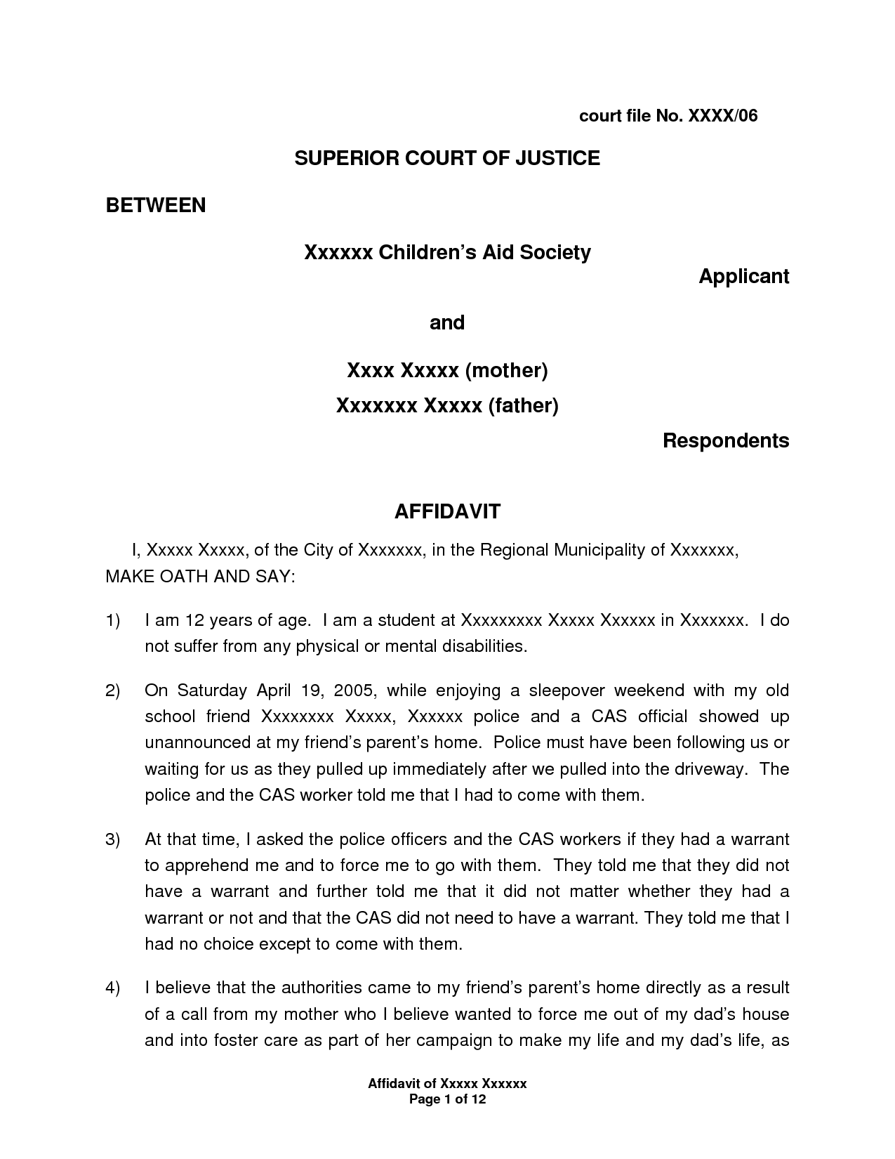
court file No. XXXX/06
SUPERIOR COURT OF JUSTICE
BETWEEN
Xxxxxx Children's Aid Society
Applicant
and
Xxxx Xxxxx (mother) Xxxxxxx Xxxxx (father)
Respondents
AFFIDAVIT
1, Xxxxx Xxxxx, of the City of Xxxxxxx, in the Regional Municipality of Xxxxxxx, MAKE OATH AND SAY:
1)
Tam 12 years of age. I am a student at XxxXXXXXX Xxxxx Xxxxxx in Xxxxxxx. I do not suffer from any physical or mental disabilities.
On Saturday April 19, 2005, while enjoying a sleepover weekend with my old school friend Xxxxxxxx Xxxxx, Xxxxxx police and a CAS official showed up unannounced at my friend's parent's home. Police must have been following us or waiting for us as they pulled up immediately after we pulled into the driveway. The police and the CAS worker told me that I had to come with them.
At that time, I asked the police officers and the CAS workers if they had a warrant to apprehend me and to force me to go with them. They told me that they did not have a warrant and further told me that it did not matter whether they had a warrant or not and that the CAS did not need to have a warrant. They told me that I had no choice except to come with them.
4)
I believe that the authorities came to my friend's parent's home directly as a result of a call from my mother who I believe wanted to force me out of my dad's house and into foster care as part of her campaign to make my life and my dad's life, as
Affidavit of Xxxxx XXXXXX
Page 1 of 12

