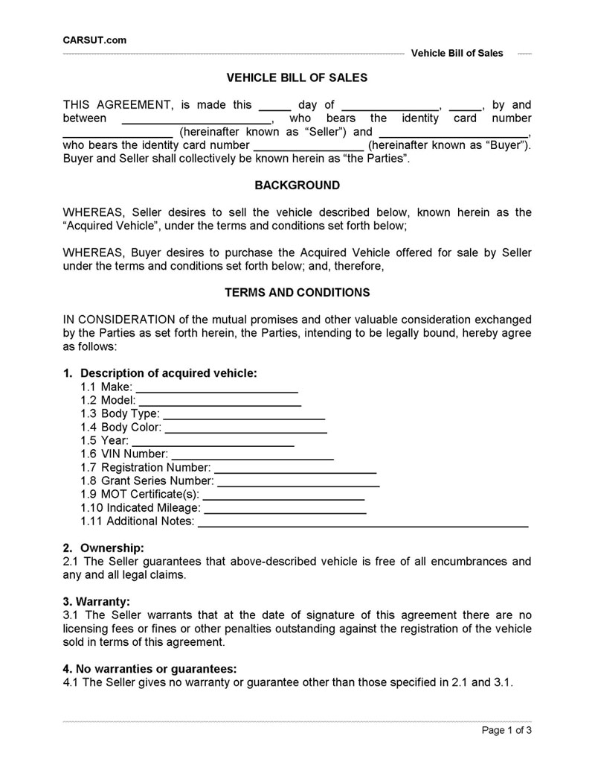
CARSUT.com
Vehicle Bill of Sales
VEHICLE BILL OF SALES
THIS AGREEMENT, is made this day of
by and between
who bears the identity card number
(hereinafter known as "Seller") and who bears the identity card number
(hereinafter known as "Buyer"). Buyer and Seller shall collectively be known herein as "the Parties".
BACKGROUND
WHEREAS, Seller desires to sell the vehicle described below, known herein as the "Acquired Vehicle", under the terms and conditions set forth below;
WHEREAS, Buyer desires to purchase the Acquired Vehicle offered for sale by Seller under the terms and conditions set forth below; and, therefore,
TERMS AND CONDITIONS
IN CONSIDERATION of the mutual promises and other valuable consideration exchanged by the parties as set forth herein, the Parties, intending to be legally bound, hereby agree as follows:
1. Description of acquired vehicle:
1.1 Make: 1.2 Model: 1.3 Body Type: 1.4 Body Color: 1.5 Year: 1.6 VIN Number: 1.7 Registration Number: 1.8 Grant Series Number: 1.9 MOT Certificate(s): 1.10 Indicated Mileage: 1.11 Additional Notes:
2. Ownership: 2.1 The Seller guarantees that above-described vehicle is free of all encumbrances and any and all legal claims.
3. Warranty: 3.1 The Seller warrants that at the date of signature of this agreement there are no licensing fees or fines or other penalties outstanding against the registration of the vehicle sold in terms of this agreement.
4. No warranties or guarantees: 4.1 The Seller gives no warranty or guarantee other than those specified in 2.1 and 3.1.
Page 1 of 3

