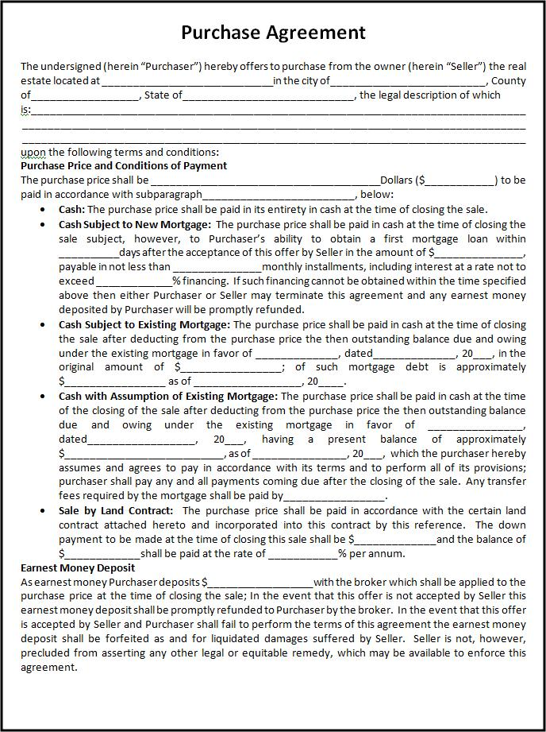
Purchase Agreement
The undersigned (herein "Purchaser") hereby offers to purchase from the owner (herein "Seller") the real estate located at
_in the city of
County -- State of __
---________, the legal description of which is:
upon the following terms and conditions: Purchase Price and Conditions of Payment The purchase price shall be _
Dollars ($_ __) to be paid in accordance with subparagraph
_below: Cash: The purchase price shall be paid in its entirety in cash at the time of closing the sale. Cash Subject to New Mortgage: The purchase price shall be paid in cash at the time of closing the sale subject, however, to Purchaser's ability to obtain a first mortgage loan within
days after the acceptance of this offer by Seller in the amount of $_ payable in not less than
monthly installments, including interest at a rate not to exceed
% financing. If such financing cannot be obtained within the time specified above then either Purchaser or Seller may terminate this agreement and any earnest money deposited by Purchaser will be promptly refunded. Cash Subject to Existing Mortgage: The purchase price shall be paid in cash at the time of closing the sale after deducting from the purchase price the then outstanding balance due and owing under the existing mortgage in favor of
_dated
_20_, in the original amount of $
_ of such mortgage debt is approximately as of_
__20____ Cash with Assumption of Existing Mortgage: The purchase price shall be paid in cash at the time of the closing of the sale after deducting from the purchase price the then outstanding balance due and owing under the existing mortgage in favor of dated
__ 20___ having a present balance of approximately as of__
_ 20_which the purchaser hereby assumes and agrees to pay in accordance with its terms and to perform all of its provisions; purchaser shall pay any and all payments coming due after the closing of the sale. Any transfer fees required by the mortgage shall be paid by_ Sale by Land Contract: The purchase price shall be paid in accordance with the certain land contract attached hereto and incorporated into this contract by this reference. The down payment to be made at the time of closing this sale shall be $
__and the balance of __shall be paid at the rate of __
% per annum. Earnest Money Deposit As earnest money Purchaser deposits $_
with the broker which shall be applied to the purchase price at the time of closing the sale; In the event that this offer is not accepted by Seller this earnest money deposit shall be promptly refunded to Purchaser by the broker. In the event that this offer is accepted by Seller and Purchaser shall fail to perform the terms of this agreement the earnest money deposit shall be forfeited as and for liquidated damages suffered by Seller. Seller is not, however, precluded from asserting any other legal or equitable remedy, which may be available to enforce this agreement.

