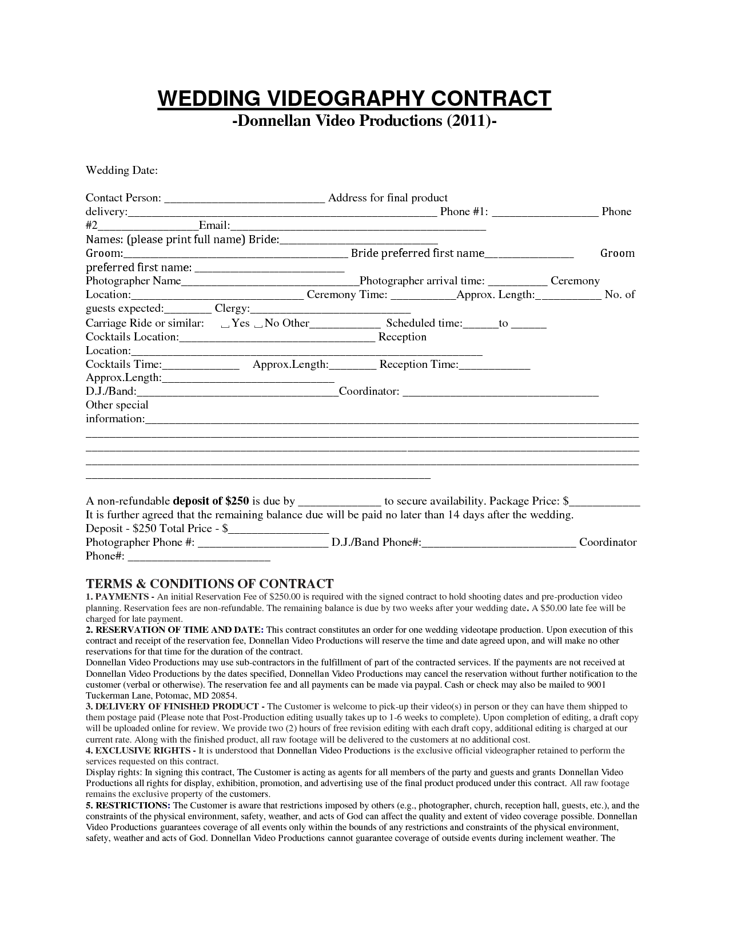
WEDDING VIDEOGRAPHY CONTRACT
-Donnellan Video Productions (2011)
Wedding Date:
Contact Person:
Address for final product delivery:
__ Phone #1:
Phone #2
Email: Names: (please print full name) Bride: Groom:
Bride preferred first name_
Groom preferred first name: Photographer Name
Photographer arrival time:
Ceremony Location:
Ceremony Time:
_Approx. Length: ____ No. of guests expected: Clergy: Carriage Ride or similar: Yes _ No Other
Scheduled time: _ to— Cocktails Location:
Reception Location: Cocktails Time:
Approx.Length: _ Reception Time: Approx.Length: D.J./Band:
Coordinator: Other special information:
A non-refundable deposit of $250 is due by
to secure availability. Package Price: $ It is further agreed that the remaining balance due will be paid no later than 14 days after the wedding. Deposit - $250 Total Price - $ Photographer Phone #: D.J./Band Phone#:_
Coordinator Phone#:
TERMS & CONDITIONS OF CONTRACT 1. PAYMENTS - An initial Reservation Fee of $250.00 is required with the signed contract to hold shooting dates and pre-production video planning. Reservation fees are non-refundable. The remaining balance is due by two weeks after your wedding date. A $50.00 late fee will be charged for late payment. 2. RESERVATION OF TIME AND DATE: This contract constitutes an order for one wedding videotape production. Upon execution of this contract and receipt of the reservation fee, Donnellan Video Productions will reserve the time and date agreed upon, and will make no other reservations for that time for the duration of the contract. Donnellan Video Productions may use sub-contractors in the fulfillment of part of the contracted services. If the payments are not received at Donnellan Video Productions by the dates specified, Donnellan Video Productions may cancel the reservation without further notification to the customer (verbal or otherwise). The reservation fee and all payments can be made via paypal. Cash or check may also be mailed to 9001 Tuckerman Lane, Potomac, MD 20854. 3. DELIVERY OF FINISHED PRODUCT - The Customer is welcome to pick-up their video(s) in person or they can have them shipped to them postage paid (Please note that Post-Production editing usually takes up to 1-6 weeks to complete). Upon completion of editing, a draft copy will be uploaded online for review. We provide two (2) hours of free revision editing with each draft copy, additional editing is charged at our current rate. Along with the finished product, all raw footage will be delivered to the customers at no additional cost. 4. EXCLUSIVE RIGHTS - It is understood that Donnellan Video Productions is the exclusive official videographer retained to perform the services requested on this contract. Display rights: In signing this contract, The Customer is acting as agents for all members of the party and guests and grants Donnellan Video Productions all rights for display, exhibition, promotion, and advertising use of the final product produced under this contract. All raw footage remains the exclusive property of the customers 5. RESTRICTIONS: The Customer is aware that restrictions imposed by others (e.g., photographer, church, reception hall, guests, etc.), and the constraints of the physical environment, safety, weather, and acts of God can affect the quality and extent of video coverage possible. Donnellan Video Productions guarantees coverage of all events only within the bounds of any restrictions and constraints of the physical environment, safety, weather and acts of God. Donnellan Video Productions cannot guarantee coverage of outside events during inclement weather. The

