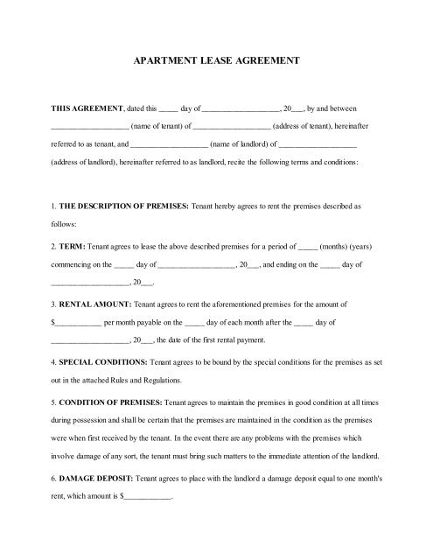
APARTMENT LEASE AGREEMENT
THIS AGREEMENT.dated this
day of
20_ by and between _address of tenant), hereinafter
_name of tenant of
referred to as tenant, and
(name of landlord of
(adress of landlord), hereinafter referred to as landlord, recite the following terms and conditions:
L. THE DESCRIPTION OF PREMISES: Tenant hereby agrees to test the premises described as
follows:
2. TERM: Tenant agrees to lease the above described premises for a period of_ months) (years) commencing on the day of
, 20 , and ending on the_ day of
3. RENTAL AMOUNT: Tenant agrees to rent the aforementioned premises for the amount of
per month payable on the day of each month after the day of
__. 20__. the date of the first rental payment
4. SPECIAL CONDITIONS: Terant agrees to be bound by the special conditions for the premises as set
out in the attached Rules and Regulations
5. CONDITION OF PREMISES: Tenant agrees to maintain the premises in good condition at all times
during possession and shall be certain that the premises are maintained in the condition as the premises
were when first received by the tenant. In the event there are any problems with the premises which
involve damage of any sort, the tenant must bring such matters to the immediate attention of the landed.
6 DAMAGE DEPOSIT: Tenant agrees to place with the landlord a damage deposits equal to one month's rent, which amount is

