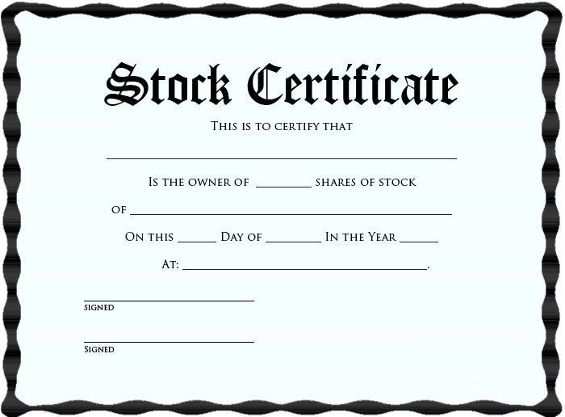
Stock Certificate
THIS IS TO CERTIFY THAT
IS THE OWNER OF
SHARES OF STOCK
OF
DAY OF
IN THE YEAR _
ON THIS
AT:__
SIGNED
SIGNED

