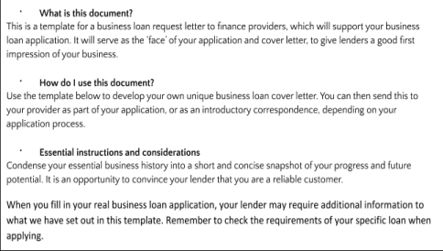https://www.thebalancesmb.com/bank-loan-application-393406 Business Loan Request Letter
Format: (You’ll probably know this part already, but here are the basics)
Date:
Applicant’s name: (Your personal name as director)
Applicant’s address:
Lender name: (An individual contact or lender name can be placed here) Lender address:
Subject: Business loan Request Letter
Dear Mr. /Ms. / Mrs.
[Insert letter text]
Sincerely,
Applicant name and signature:
Applicant’s contact information:
Information to include:
1. The intention of the letter

State the purpose of this letter clearly in the first sentence, detailing the type of loan you would like to take out and the amount.
2. An engaging insight into your business
You’ll need to provide an overview of your business and the nature of your services. As well as the basics, you should cover the aspects that are unique to your business and may help make you stand out from other enterprises in your sector.
- Business legal name
- Type of business (e.g. LLC, Sole Trader, Partnership etc.)
- Nature of business
- Main services and products
- Business model
- Number of employees
- Annual generated revenue
3. Explain what the loan is for
As well as stating the obvious, in that the funding will support long-term growth and improve the profitability of your company, outline the specifics of how you plan to use your business loan.
As well as giving confidence to lenders that you know what you’re doing, you will also be giving them additional context about your business and your position within it. A classic action + result format here is a good one to use. Here’s an example:
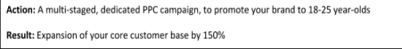

Below is a list of additional purposes you might use the loan for:
- To purchase commercial property
- To purchase equipment
- To purchase stock
- To increase working capital
- To expand your workforce
- To fund marketing campaigns
- To hire better talent
- To move your offices to a new location
- To open additional offices in a new location
- To buy business insurance
- To merge with or acquire another company
- To buy out shareholders
- To start building your credit for a larger future loan
This is by no means an exhaustive list and many more scenarios can be added. Just make sure to outline that the loan will serve a fundamental purpose in your business and will be used to improve your long-term growth potential.
Don’t forget that as interesting as your business might be to you, the underlying message your lender wants to hear is that you have a plan for how it can make more money. As such, add the positive ‘result’ of every action you are going to take with your business loan.
4. Explain how you will pay back the loan and manage repayments
While you will detail exactly how the loan will be repaid, it is worth explaining that you will be able to meet these demands and how exactly you plan to effectively manage the outstanding debt, plus any interest over the loan term.
You can use figures from your profit projections or past statements that you have, to prove you will be able to pay back each instalment. If you have other outstanding debt, be sure to inform the lender that you will be able to sufficiently factor in your new business loan into your current business debt schedule.
Any specific contingencies or assets can also be used to persuade lenders that you will have the ability to pay back the loan, even if you are not able to meet the estimated profit projections that have laid out in your business plan. Ultimately, you are trying to convey a sense of your business’s health and low-risk levels.
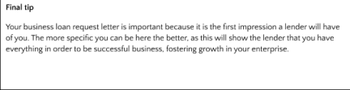
Example business loan request letter Dear [LENDER’S NAME],

I am writing to you to request a business loan of [LOAN AMOUNT] for the purpose of expanding the potential of my [TYPE OF BUSINESS] business, [BUSINESS NAME]. As a successful provider of [PRIMARY PRODUCTS / SERVICES], with an established brand and growing customer base in the UK, I would like to build on our current progress over the next [INSERT TIME FRAME].
A [INSERT LOAN TYPE] provided through you over a term of [INSERT AMOUNT] months should provide us with the budget required to invest in the necessary [INSERT GROWTH STRATEGY SUMMARY] that will allow us to further our position in the market.
The business, which is a [INSERT BUSINESS TYPE (LLC, LC etc.)] now employs [AMOUNT] individuals and functions as a UK-focused [INSERT NATURE OF BUSINESS]. Our team is made up of [INSERT INFORMATION ON DIRECTORS AND PARTNERS] who manage staff and are involved in [EXPLAIN DIRECTOR ROLES].
Last year, we generated [AMOUNT] in sales of our primary product and we plan to capitalise on this progress by releasing new products, aimed at capturing the interest of our growing customer base and target market.
Specifically, we would use the loan to
[EXPLAIN PRIMARY PURPOSE OF THE LOAN REFERRING TO YOUR BUSINESS PLAN] +[EXPLAIN ADDITIONAL PURPOSES FOR THE LOAN REFERRING TO YOUR BUSINESS PLAN]
Based on our careful calculations and our estimated sale forecasts over the next [INSERT TIME FRAME], we believe we will be able to easily manage the repayment of this loan over the specified time frame. You can see from our business plan and existing debt history that both monthly repayments and accumulating interest can be paid back in full, based on the continued success of the business.
As a business, we also have extremely low overheads and the ability to work with contract or freelance employees, should business demand fluctuate. This will give us the flexibility to maintain debt repayments, even if our current profit projections are not fully realised.
We would like to receive the business loan immediately, to make the most of our current growth period and would, therefore, be willing to provide any additional documentation information as promptly as possible. If you would like to clarify anything from our business plan or loan application, please don’t hesitate to ask.

Finally, we greatly appreciate the time you have taken to review this application and look forward to your response.
Sincerely,
[INSERT DIRECTOR NAMES + BUSINESS NAME]

