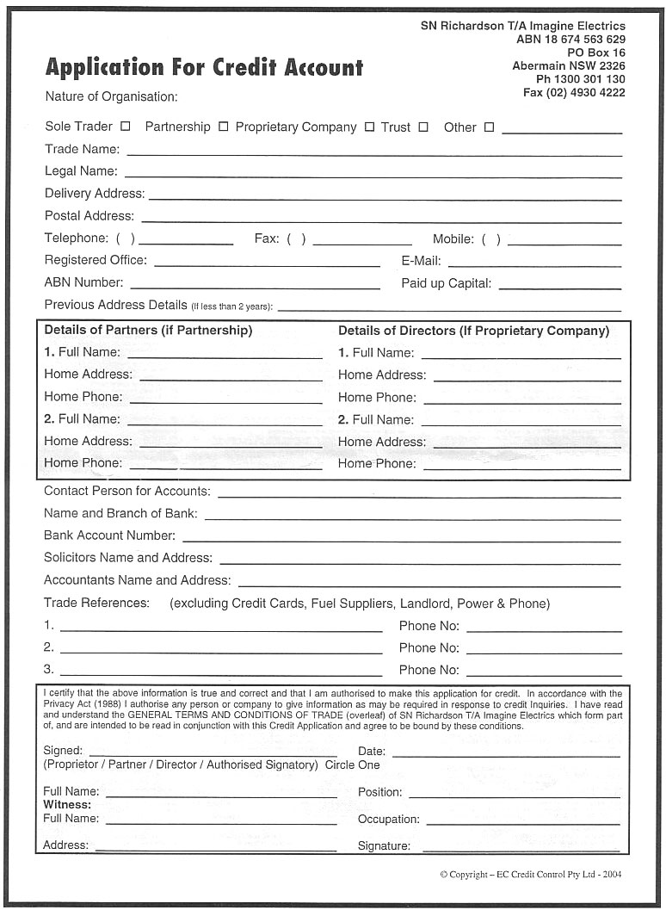
Application For Credit Account Nature of Organisation:
SN Richardson T/A Imagine Electrics
ABN 18 674 563 629
PO Box 16 Abermain NSW 2326
Ph 1300 301 130 Fax (02) 4930 4222
Sole Trader Partnership Proprietary Company Trust Other Trade Name: Legal Name: Delivery Address: Postal Address: Telephone: ().
Fax: ( )
Mobile: () Registered Office:
E-Mail: ABN Number:
Paid up Capital: Previous Address Details (if less than 2 years): – Details of Partners (if Partnership)
Details of Directors (If Proprietary Company) 1. Full Name:
1. Full Name: Home Address:
Home Address: Home Phone:
Home Phone: 2. Full Name:
2. Full Name: Home Address:
Home Address: Home Phone:
Home Phone:
Contact Person for Accounts: Name and Branch of Bank: Bank Account Number: Solicitors Name and Address: Accountants Name and Address: Trade References: (excluding Credit Cards, Fuel Suppliers, Landlord, Power & Phone)
Phone No: Phone No: Phone No:
I certify that the above information is true and correct and that I am authorised to make this application for credit. In accordance with the Privacy Act (1988) I authorise any person or company to give information as may be required in response to credit Inquiries. I have read and understand the GENERAL TERMS AND CONDITIONS OF TRADE (overleaf) of SN Richardson T/A Imagine Electrics which form part of, and are intended to be read in conjunction with this Credit Application and agree to be bound by these conditions.
Signed:
Date: (Proprietor / Partner / Director / Authorised Signatory) Circle One
Position:
Full Name: Witness: Full Name:
Occupation: Signature:
Address:
Copyright -- EC Credit Control Pty Ltd - 2004

