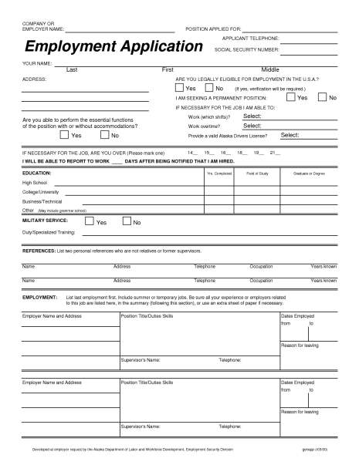COMPANY OR EMPLOYER NAME:
POSITION APPLIED FOR:
APPLICANT TELEPHONE:
Employment
Application sociais
SOCIAL SECURITY NUMBER:
YOUR NAME:
Last
ADDRESS:
Dres
No
First
Middle ARE YOU LEGALLY ELIGIBLE FOR EMPLOYMENT IN THE U.S.A.? Yes No (If yes, verification will be required.) I AM SEEKING A PERMANENT POSITION: IF NECESSARY FOR THE JOB I AM ABLE TO:
Work (which shifts)? Select: Work overtime? Select: Provide a valid Alaska Drivers License ? Select:
Are you able to perform the essential functions of the position with or without accommodations?
Yes No
19_
21_
IF NECESSARY FOR THE JOB, ARE YOU OVER (Please mark one) 14_ 15_ 16_ 18_ I WILL BE ABLE TO REPORT TO WORK DAYS AFTER BEING NOTIFIED THAT I AM HIRED.
EDUCATION:
Yrs. Completed
Field of Study
Graduate or Degree
High School College/University Business/Technical
Other (May include grammar school)
MILITARY SERVICE:
MILITARY SERVICE:
Yes
Yes
No
Duty/Specialized Training:
REFERENCES: List two personal references who are not relatives or former supervisors.
Name
Address
Telephone
Occupation
Years known
Name
Address
Telephone
Occupation
Years known
EMPLOYMENT:
List last employment first. Include summer or temporary jobs. Be sure all your experience or employers related to this job are listed here, in the summary (following this section), or use an extra sheet of paper if necessary.
Employer Name and Address
Position Title/Duties Skills
Dates Employed from
to
Reason for leaving
Supervisor's Name:
Telephone:
Employer Name and Address
Position Title/Duties Skills
Dates Employed from
to
Reason for leaving
Supervisor's Name:
Telephone:
Developed at employer request by the Alaska Department of Labor and Workforce Development, Employment Security Division
genapp (r03/00)

