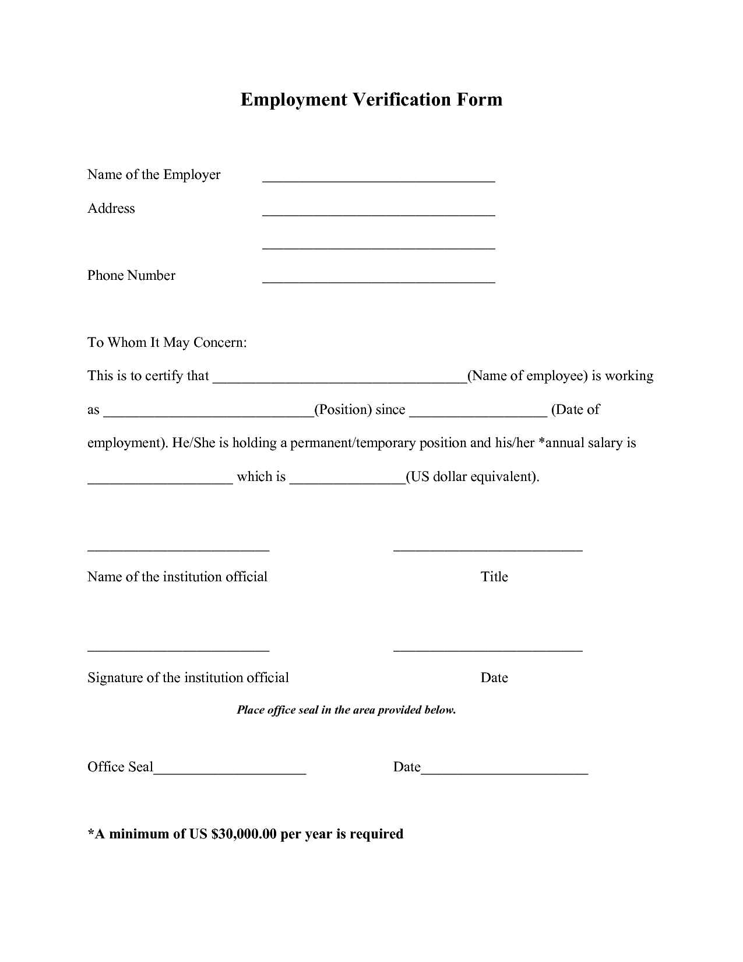
Employment Verification Form
Name of the Employer
Address
Phone Number
To Whom It May Concern:
This is to certify that
_(Name of employee) is working
as
(Position) since
(Date of
employment). He/She is holding a permanent/temporary position and his/her *annual salary is
which is
(US dollar equivalent).
Name of the institution official
Title
Signature of the institution official
Date
Place office seal in the area provided below.
Office Seal
Date
*A minimum of US $30,000.00 per year is required

