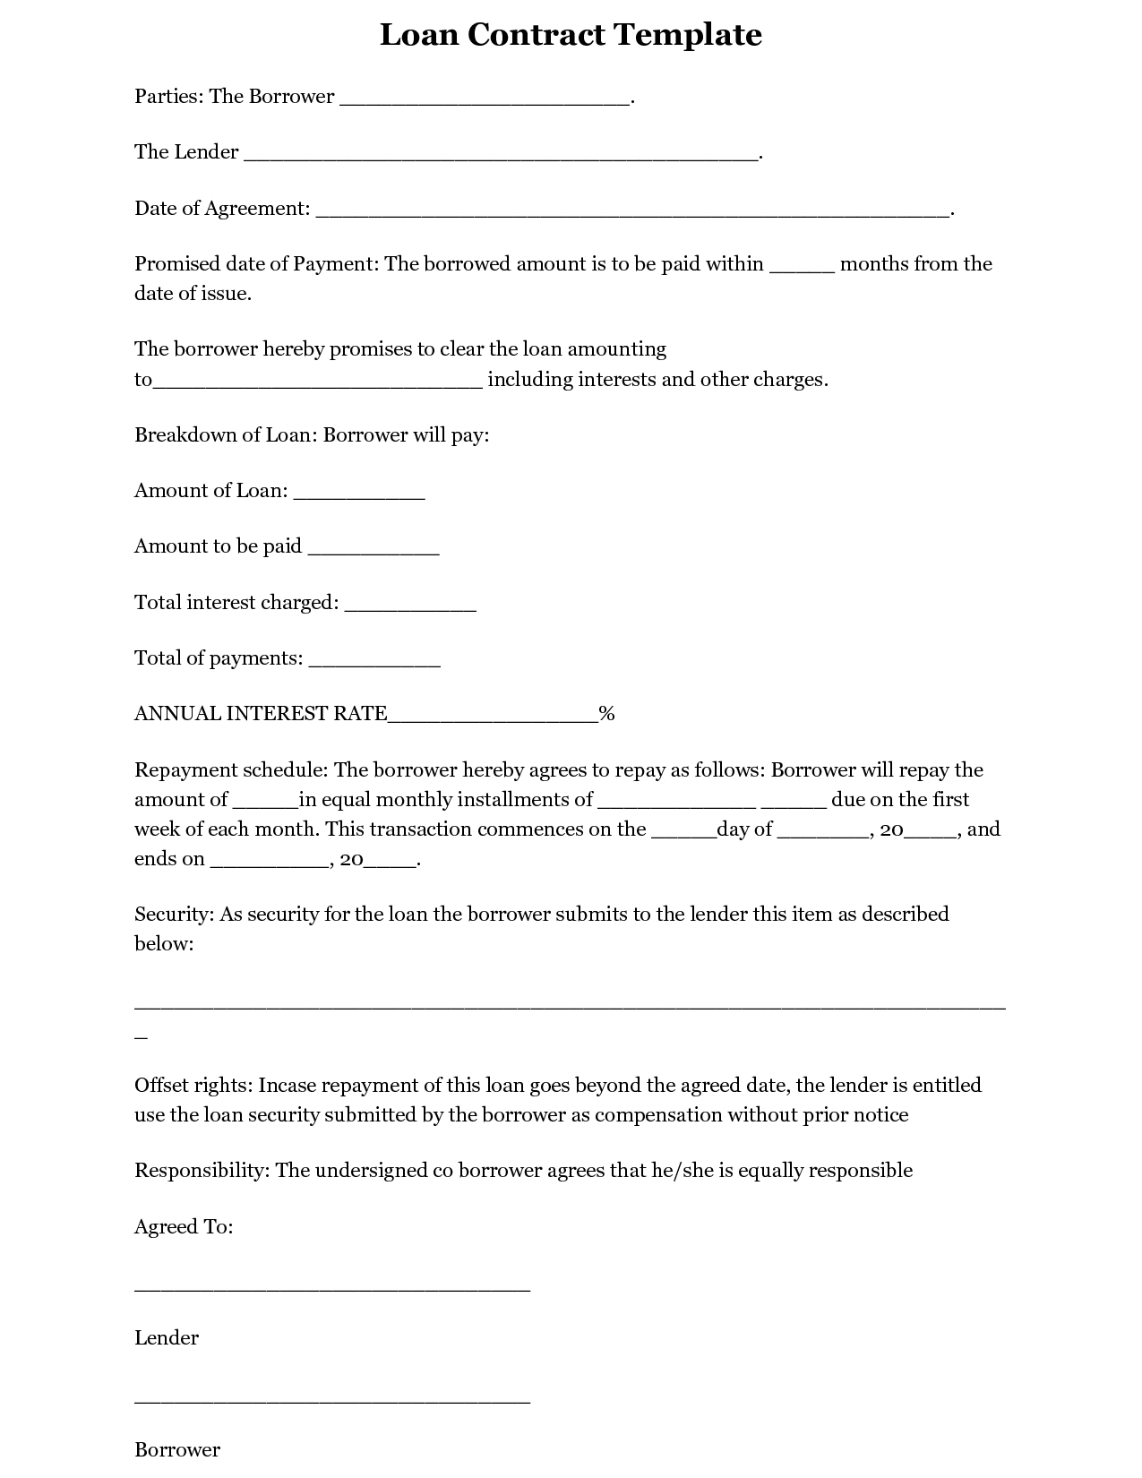
Loan Contract Template
Parties: The Borrower
The Lender
Date of Agreement:
months from the
Promised date of Payment: The borrowed amount is to be paid within date of issue.
The borrower hereby promises to clear the loan amounting
_including interests and other charges.
to
Breakdown of Loan: Borrower will pay:
Amount of Loan:
Amount to be paid
Total interest charged:
Total of payments:
ANNUAL INTEREST RATE_
%
-
-
Repayment schedule: The borrower hereby agrees to repay as follows: Borrower will repay the amount of in equal monthly installments of
due on the first week of each month. This transaction commences on the ___day of __ , 20___, and ends on
_, 20__
Security: As security for the loan the borrower submits to the lender this item as described below:
Offset rights: Incase repayment of this loan goes beyond the agreed date, the lender is entitled use the loan security submitted by the borrower as compensation without prior notice
Responsibility: The undersigned co borrower agrees that he/she is equally responsible
Agreed To:
Lender
Borrower

