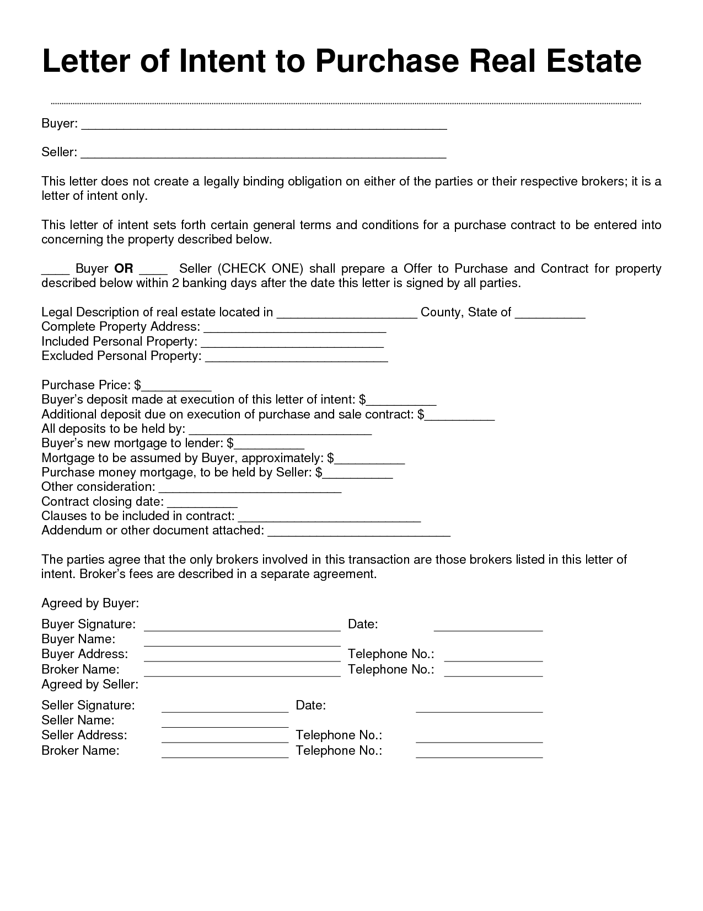
Letter of Intent to Purchase Real Estate
Buyer:
Seller:
This letter does not create a legally binding obligation on either of the parties or their respective brokers; it is a letter of intent only.
This letter of intent sets forth certain general terms and conditions for a purchase contract to be entered into concerning the property described below.
Buyer OR Seller (CHECK ONE) shall prepare a Offer to Purchase and Contract for property described below within 2 banking days after the date this letter is signed by all parties.
County, State of
Legal Description of real estate located in Complete Property Address: Included Personal Property: Excluded Personal Property:
Purchase Price: $_ Buyer's deposit made at execution of this letter of intent: $ Additional deposit due on execution of purchase and sale contract: $ All deposits to be held by: Buyer's new mortgage to lender: $ Mortgage to be assumed by Buyer, approximately: $ Purchase money mortgage, to be held by Seller: $_ Other consideration: Contract closing date: Clauses to be included in contract: Addendum or other document attached:
The parties agree that the only brokers involved in this transaction are those brokers listed in this letter of intent. Broker's fees are described in a separate agreement.
Date:
Telephone No.: Telephone No.:
Agreed by Buyer: Buyer Signature: Buyer Name: Buyer Address: Broker Name: Agreed by Seller: Seller Signature: Seller Name: Seller Address: Broker Name:
Date:
Telephone No.: Telephone No.:

