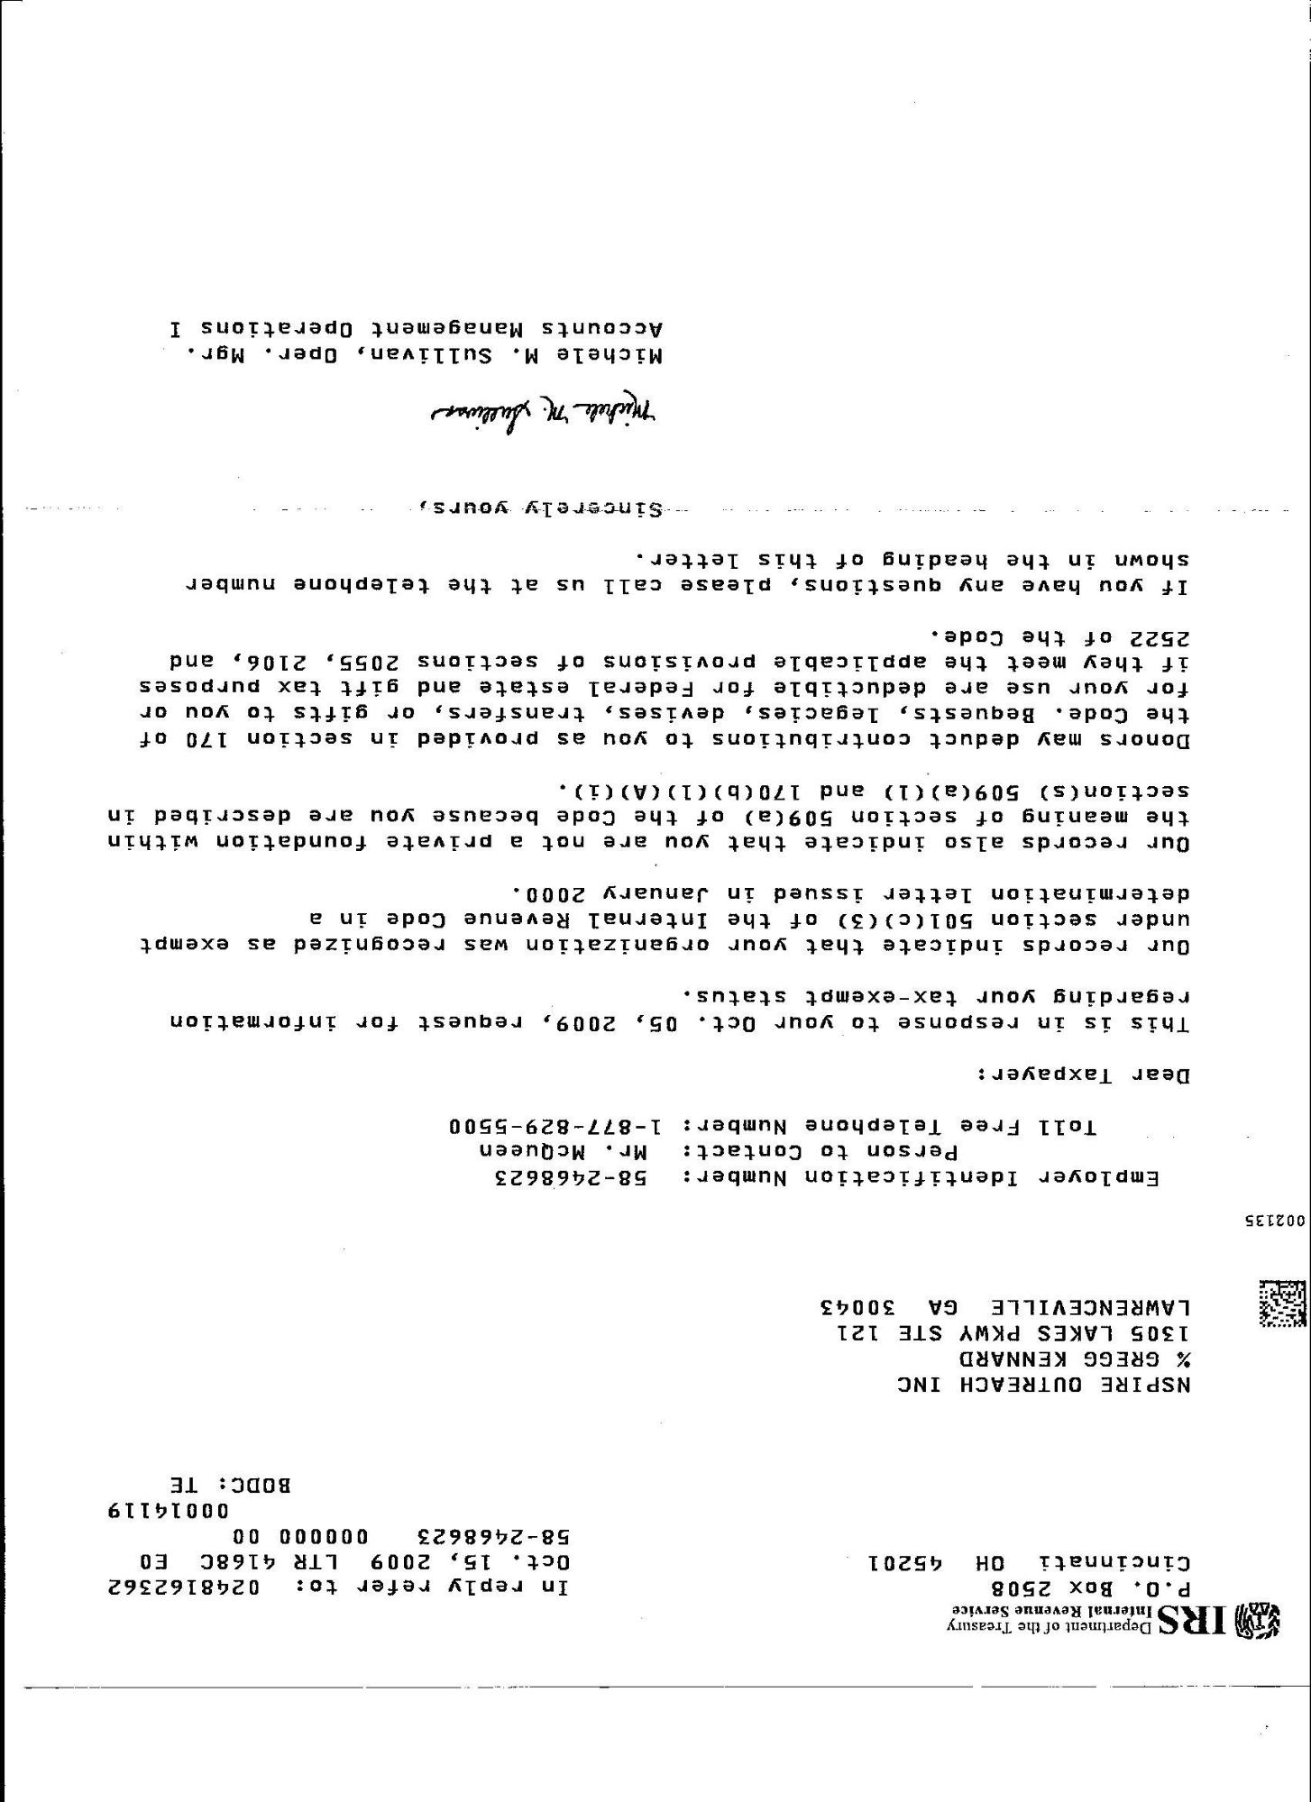
-..
. --
--
TWID Department of the Treasury
Internal Revenue Service P.0. Box 2508 Cincinnati OH 45201
In reply refer to: 0248162362 Oct 15, 2009 LTR 4168CEO 58-2468623 00000000
00014119 BODC: TE
NSPIRE OUTREACH INC % GREGG KENNARD 1305 LAKES PKWY STE 121 LAWRENCEVILLE GA 30043
002135
Employer Identification Number: 58-2468623
Person to Contact: Mr. McQueen Toll Free Telephone Number: 1-877-829-5500
Dear Taxpayer:
This is in response to your Oct. 05, 2009, request for information regarding your tax-exempt status.
Our records indicate that your organization was recognized as exempt under section 501(c)(3) of the Internal Revenue Code in a determination letter issued in January 2000.
Our records also indicate that you are not a private foundation within the meaning of section 509(a) of the Code because you are described in section(s) 509(a) (1) and 170 (b) (1) (A) (i).
Donors may deduct contributions to you as provided in section 170 of the Code. Bequests, legacies, devises, transfers, or gifts to you or for your use are deductible for Federal estate and gift tax purposes if they meet the applicable provisions of sections 2055, 2106, and 2522 of the Code.
If you have any questions, please call us at the telephone number shown in the heading of this letter.
.
-
.......
.
.....
... ...
---SinCATALV VOurs
.
-
-
Michele M. Sulleres
Michele M. Sullivan, Oper. Mgr.. Accounts Management Operations I

