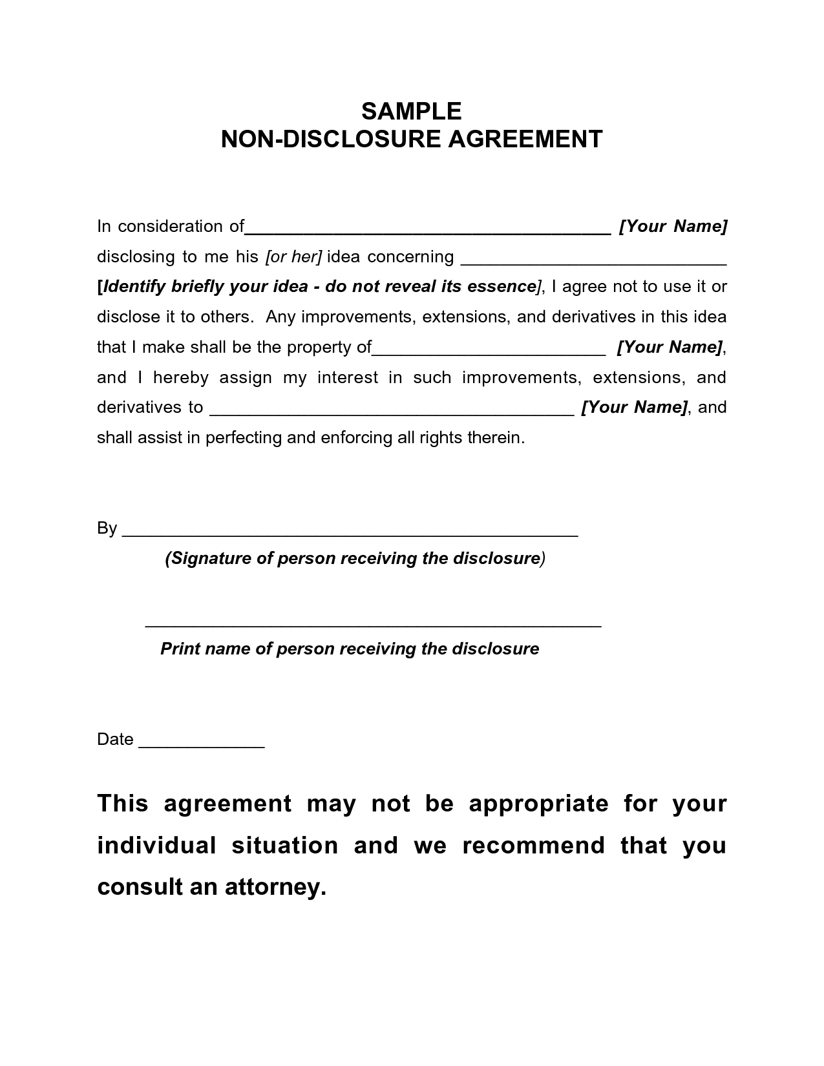
SAMPLE NON-DISCLOSURE AGREEMENT
In consideration of
[Your Name] disclosing to me his sor her] idea concerning [Identify briefly your idea - do not reveal its essence], I agree not to use it or disclose it to others. Any improvements, extensions, and derivatives in this idea that I make shall be the property of
_[Your Name], and I hereby assign my interest in such improvements, extensions, and derivatives to
_ [Your Name), and shall assist in perfecting and enforcing all rights therein.
By
(Signature of person receiving the disclosure)
Print name of person receiving the disclosure
Date
This agreement may not be appropriate for your individual situation and we recommend that you
consult an attorney.

