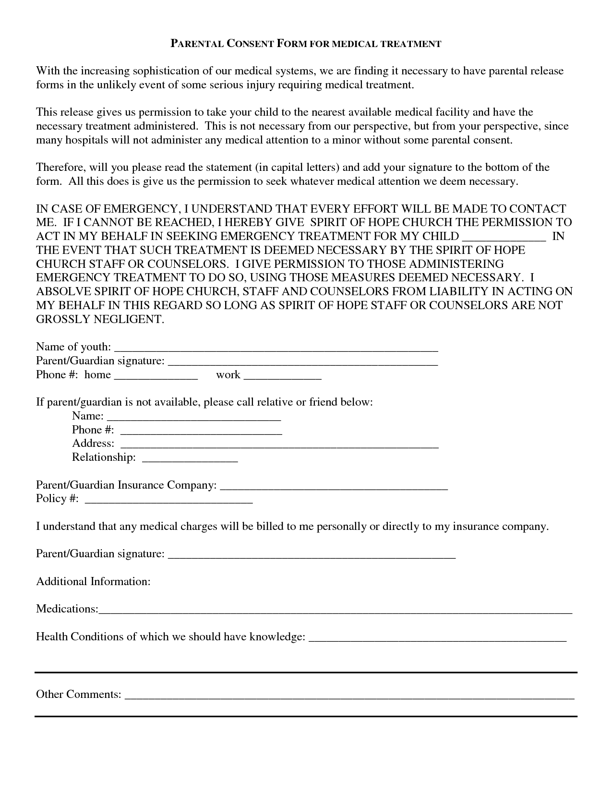
PARENTAL CONSENT FORM FOR MEDICAL TREATMENT
With the increasing sophistication of our medical systems, we are finding it necessary to have parental release forms in the unlikely event of some serious injury requiring medical treatment.
This release gives us permission to take your child to the nearest available medical facility and have the necessary treatment administered. This is not necessary from our perspective, but from your perspective, since many hospitals will not administer any medical attention to a minor without some parental consent.
Therefore, will you please read the statement in capital letters) and add your signature to the bottom of the form. All this does is give us the permission to seek whatever medical attention we deem necessary.
IN CASE OF EMERGENCY, I UNDERSTAND THAT EVERY EFFORT WILL BE MADE TO CONTACT ME. IF I CANNOT BE REACHED, I HEREBY GIVE SPIRIT OF HOPE CHURCH THE PERMISSION TO ACT IN MY BEHALF IN SEEKING EMERGENCY TREATMENT FOR MY CHILD
IN THE EVENT THAT SUCH TREATMENT IS DEEMED NECESSARY BY THE SPIRIT OF HOPE CHURCH STAFF OR COUNSELORS. I GIVE PERMISSION TO THOSE ADMINISTERING EMERGENCY TREATMENT TO DO SO, USING THOSE MEASURES DEEMED NECESSARY. I ABSOLVE SPIRIT OF HOPE CHURCH, STAFF AND COUNSELORS FROM LIABILITY IN ACTING ON MY BEHALF IN THIS REGARD SO LONG AS SPIRIT OF HOPE STAFF OR COUNSELORS ARE NOT GROSSLY NEGLIGENT.
Name of youth: Parent/Guardian signature: Phone #: home
work
If parent/guardian is not available, please call relative or friend below:
Name: Phone #: Address: Relationship:
Parent/Guardian Insurance Company: Policy #:
I understand that any medical charges will be billed to me personally or directly to my insurance company.
Parent/Guardian signature:
Additional Information:
Medications:
Health Conditions of which we should have knowledge:
Other Comments:

