ff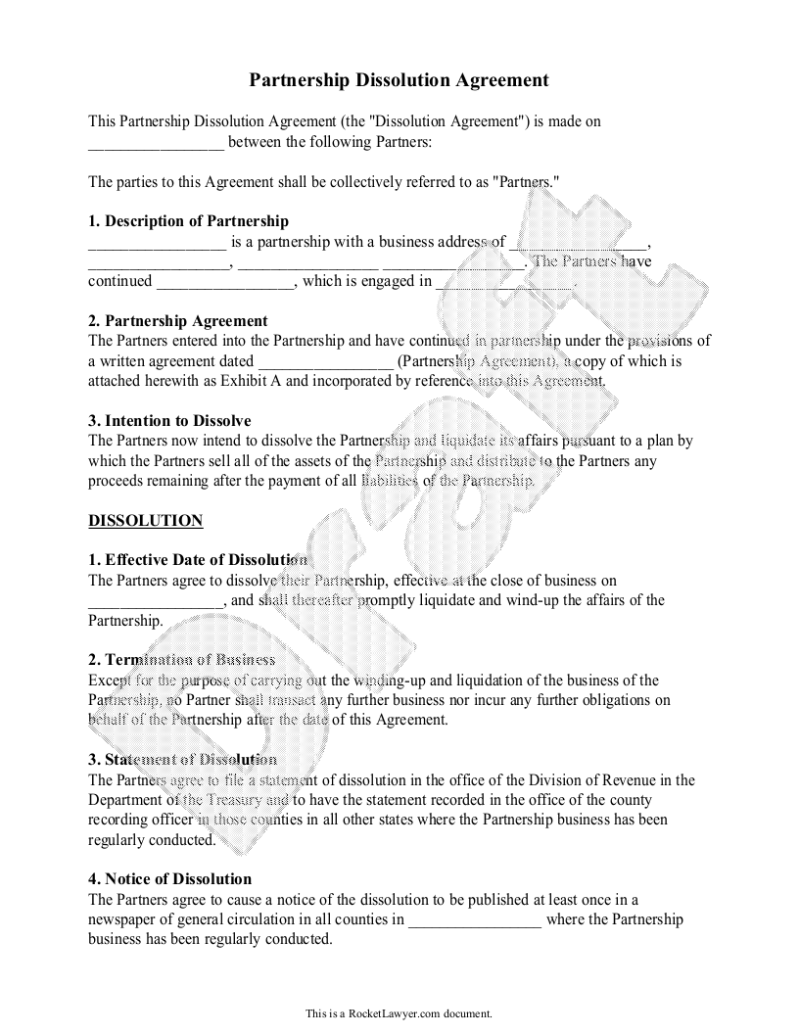
Partnership Dissolution Agreement
This Partnership Dissolution Agreement (the "Dissolution Agreement") is made on
between the following Partners:
The parties to this Agreement shall be collectively referred to as "Partners."
1. Description of Partnership
_ is a partnership with a business address of
The Partners have
continued
__, which is engaged in
2. Partnership Agreement The Partners entered into the Partnership and have continued in parinership under the provisions of a written agreement dated
(Partnership Agreement), a copy of which is attached herewith as Exhibit A and incorporated by reference into this Agreement.
3. Intention to Dissolve The Partners now intend to dissolve the Partnership and liquidate its affairs pursuant to a plan by which the Partners sell all of the assets of the Partnership and distribute to the Partners any proceeds remaining after the payment of all liabilities of the Partnership
DISSOLUTION
1. Effective Date of Dissolution The Partners agree to dissolve their Partnership, effective at the close of business on
, and shall thereafter promptly liquidate and wind-up the affairs of the Partnership.
2. Termination of Business Except for the purpose of carrying out the winding-up and liquidation of the business of the Partnership, 00 Partner shall transact any further business nor incur any further obligations on behalf of the Partnership after the date of this Agreement.
3. Statement of Dissolution The Partners agree to file a statement of dissolution in the office of the Division of Revenue in the Department of the Treasury and to have the statement recorded in the office of the county recording officer in those counties in all other states where the Partnership business has been regularly conducted.
4. Notice of Dissolution The Partners agree to cause a notice of the dissolution to be published at least once in a newspaper of general circulation in all counties in
where the Partnership business has been regularly conducted.
This is a Rocket Lawyer.com document.

