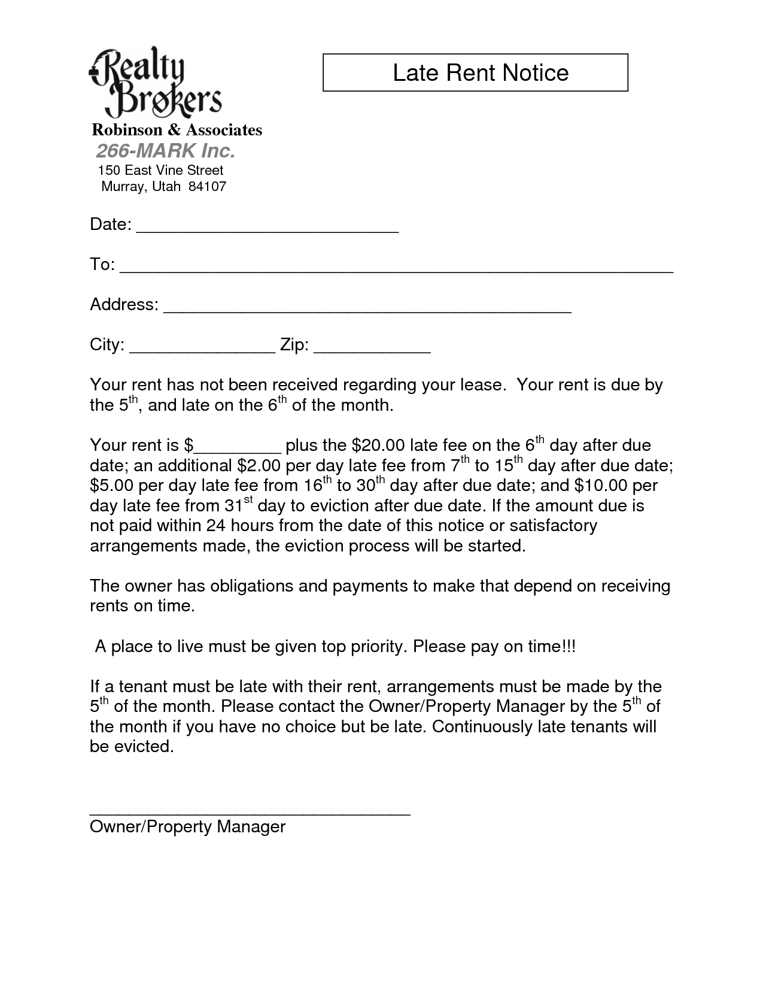
Realty Brokers
Late Rent Notice
Robinson & Associates 266-MARK Inc. 150 East Vine Street Murray, Utah 84107
Date:
To:
Address:
City:
Zip:
Your rent has not been received regarding your lease. Your rent is due by the 5th, and late on the 6th of the month.
Your rent is $_
plus the $20.00 late fee on the 6th day after due date; an additional $2.00 per day late fee from 7h to 15" day after due date; $5.00 per day late fee from 16th to 30th day after due date; and $10.00 per day late fee from 31st day to eviction after due date. If the amount due is not paid within 24 hours from the date of this notice or satisfactory arrangements made, the eviction process will be started.
The owner has obligations and payments to make that depend on receiving rents on time.
A place to live must be given top priority. Please pay on time!!!
If a tenant must be late with their rent, arrangements must be made by the 5th of the month. Please contact the Owner/Property Manager by the 5th of the month if you have no choice but be late. Continuously late tenants will be evicted.
Owner/Property Manager

