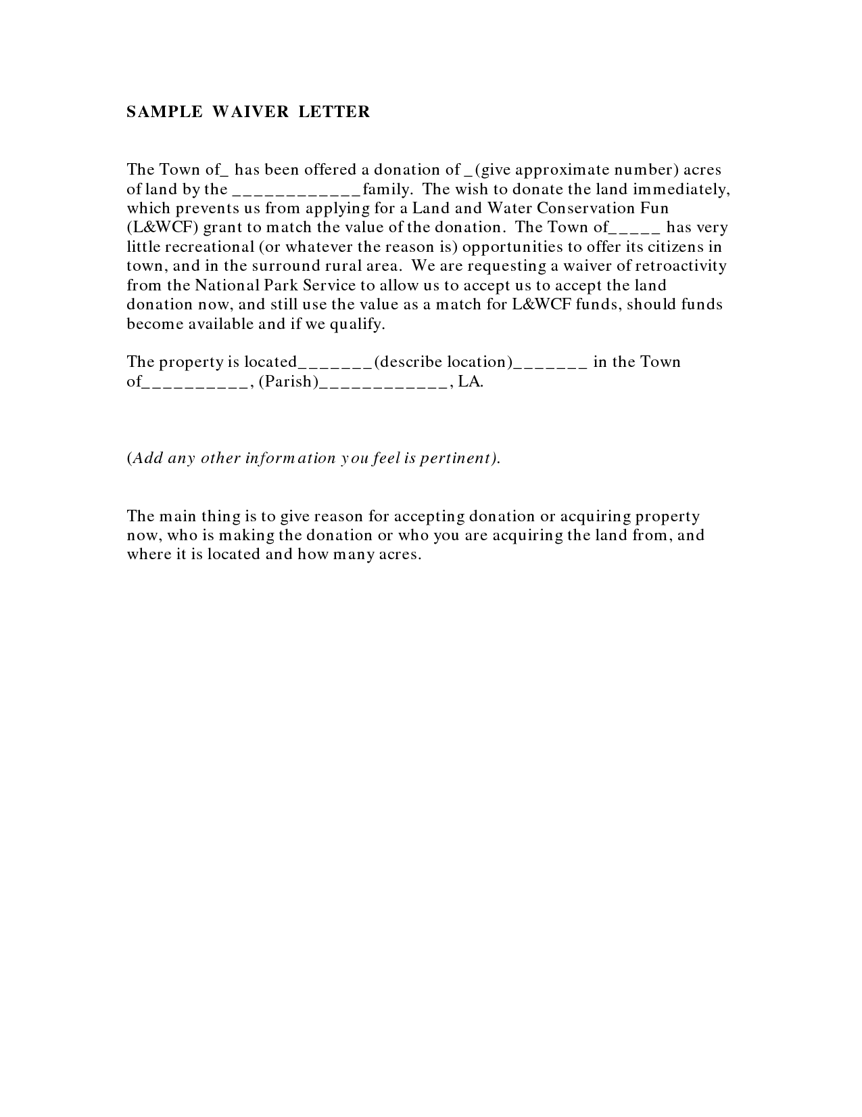
SAMPLE WAIVER LETTER
The Town of_has been offered a donation of _ (give approximate number) acres of land by the -----
____family. The wish to donate the land immediately, which prevents us from applying for a Land and Water Conservation Fun (L&WCF) grant to match the value of the donation. The Town of_____has very little recreational (or whatever the reason is) opportunities to offer its citizens in town, and in the surround rural area. We are requesting a waiver of retroactivity from the National Park Service to allow us to accept us to accept the land donation now, and still use the value as a match for L&WCF funds, should funds become available and if we qualify.
The property is located_-_-_-_(describe location) ------ in the Town of__________, (Parish) -----------, LA.
(Add any other information you feel is pertinent).
The main thing is to give reason for accepting donation or acquiring property now, who is making the donation or who you are acquiring the land from, and where it is located and how many acres.

