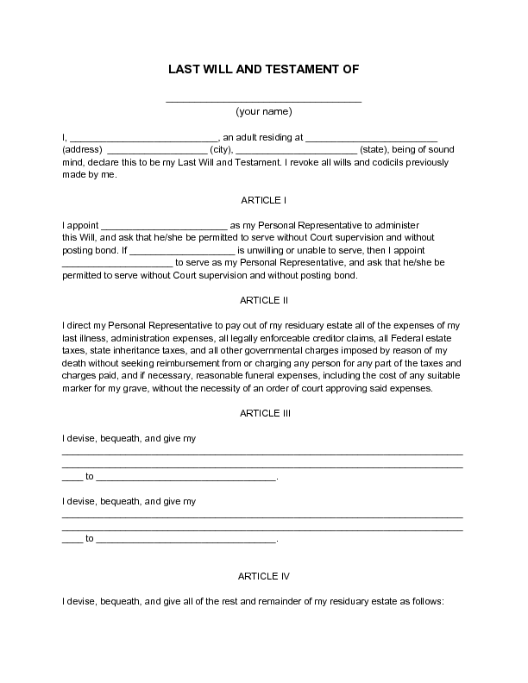
LAST WILL AND TESTAMENT OF
(your name)
, an adult residing at (address) (city),
(state), being of sound mind, declare this to be my Last Will and Testament. I revoke all wills and codicils previously made by me.
ARTICLE
I appoint
as my Personal Representative to administer this Will, and ask that he/she be permitted to serve without Court supervision and without posting bond. If
is unwilling or unable to serve, then I appoint
_to serve as my Personal Representative, and ask that he/she be permitted to serve without Court supervision and without posting bond.
ARTICLE II
I direct my Personal Representative to pay out of my residuary estate all of the expenses of my last illness, administration expenses, all legally enforceable creditor claims, all Federal estate taxes, state inheritance taxes, and all other governmental charges imposed by reason of my death without seeking reimbursement from or charging any person for any part of the taxes and charges paid, and if necessary, reasonable funeral expenses, including the cost of any suitable marker for my grave, without the necessity of an order of court approving said expenses.
ARTICLE III
I devise, bequeath, and give my
I devise, bequeath, and give my
to
ARTICLE IV
I devise, bequeath, and give all of the rest and remainder of my residuary estate as follows:

