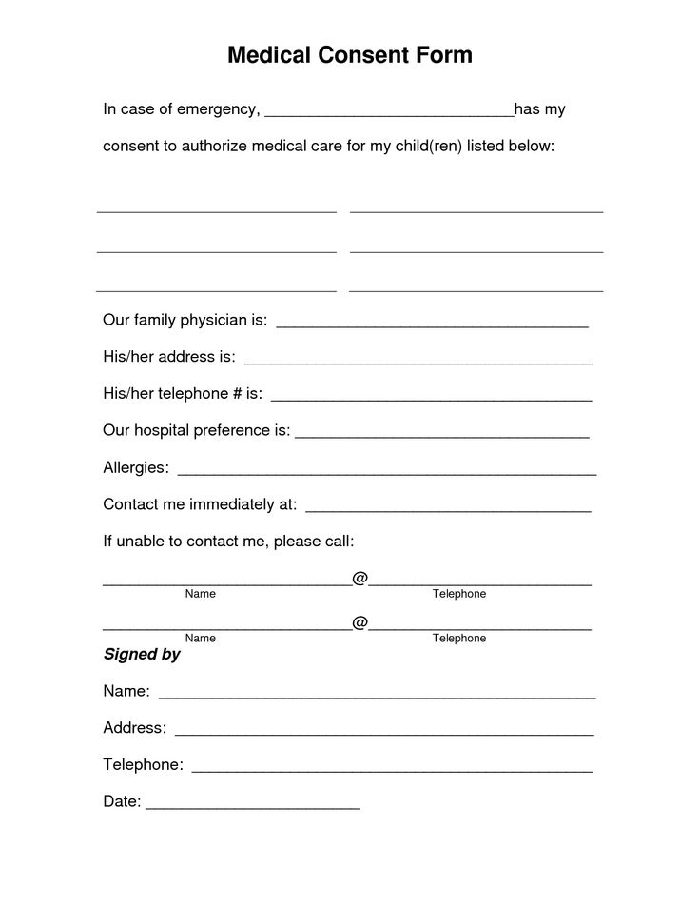
Medical Consent Form
In case of emergency,
has my
consent to authorize medical care for my child(ren) listed below:
Our family physician is:
His/her address is:
His/her telephone # is:
Our hospital preference is:
Allergies:
Contact me immediately at:
If unable to contact me, please call:
Name
Telephone
Name
Telephone
Signed by
Name:
Address:
Telephone:
Date:

