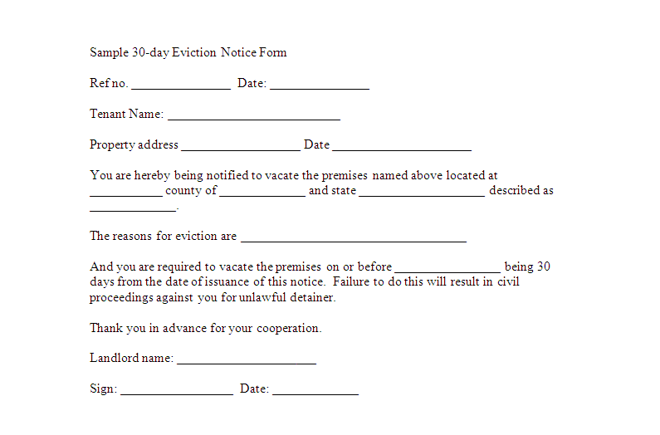
Sample 30-day Eviction Notice Form
Refno.
Date:
Tenant Name:
Property address
Date
You are hereby being notified to vacate the premises named above located at county of _and state
described as
The reasons for eviction are
And you are required to vacate the premises on or before
being 30 days from the date of issuance of this notice. Failure to do this will result in civil proceedings against you for unlawful detainer.
Thank you in advance for your cooperation.
Landlord name:
Sign: _
Date:

