**selections of Rishi teas, Coke products during dining service** and one serving of custom dessert per guest.

guests to enjoy. **Dessert service is $8.00 per guest**. **This includes: unlimited Valentine™ regular and decaf coffee,**

Sheridan’s offers a variety of delicious cake selections by our very own Pastry Chef for

Dessert & Beverage Service…

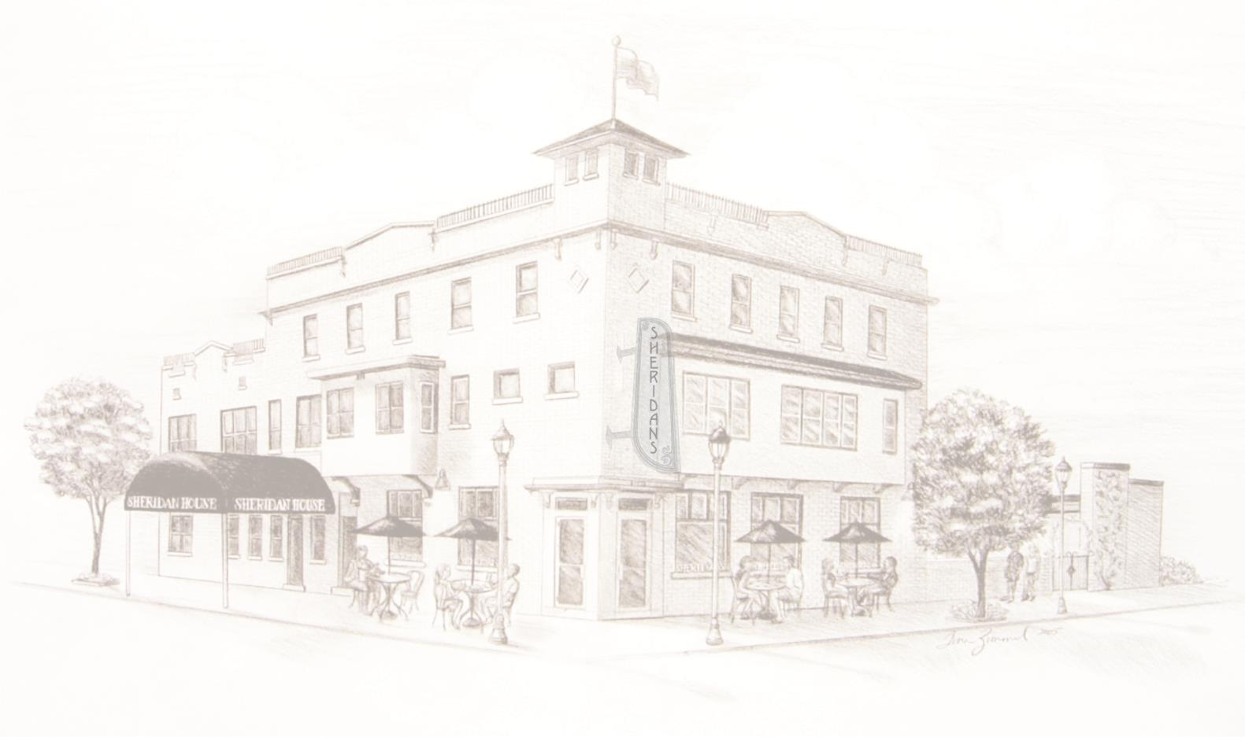

•

Add an additional 5.65% sales/expo tax and 20% service fee will be added to final bill.

•

You may

Several bar options are available such as Hosted, Cash or an On Consumption set limit.

•

Menu selections may be customized on proportions or dietary variations to fit your needs.

five (5) courtyard rooms for a one (1) night stay each.

rooms with a minimum two (2) night stay. Outdoor wedding/receptions or fire pit rental will require an additional

•

A minimum of two (2) hotel guestrooms must be reserved for weekend events. Weekday events require two (2) hotel

•

BISTRO 414.747.9800 HOTEL: 414.747.9810

5133 S. LAKE DRIVE - CUDAHY, WI 53110

**SHERIDAN’S & SHERIDAN HOUSE . . . An AMERICAN STYLE BISTRO AND BOUTIQUE HOTEL**

with prior approval by management.

outdoor courtyard, weather permitting. Floor plans can be customized to fit your ceremony needs and total number of guests

Sheridan’s is pleased to hold your intimate ceremony in our restaurant or in our

The Moment You Say “I Do” …

Ceremony

bartender/barista offers coffee drinks, cocktails, wine and a selection of bottled import, domestic and craft beers.

choose to serve a cake supplied by an outside licensed bakery with a service fee of $1.75 per slice per person. Our

**Email: _____________________________________________________________________________**

final payment.

is cancelled at any time you forfeit the rental fee. The day of your event we accept all major credit cards or a cashier check for

difference if your guest count is below the agreed upon minimum. The minimum does not include children’s dinners. If event

guarantee guest count and menu selections seven business days prior to your event. You as our patron agree to pay the

**the close of your event $200.00 of that fee will be applied to your total balance due.** Booking an event requires a

of **anticipated attendee’s** ____________. This fee is nonrefundable and is required upon booking to reserve your date. **At**

Our reservation fee is $500.00 for the **date_**______________ of your private event. Number

Facility Rate Information…

our fees and services pertains to holding a wedding at Sheridan's.

amenities. We are happy to assist you in planning a wedding distinctly tailored to your needs. The following information on

event you and your guests will ever attend. We take pride in providing our guests with the highest quality cuisine, service and

When you choose to celebrate your wedding at Sheridan's, it becomes our mission to make it the most special and memorable

Wedding Planning Details & Contract



Sheridan’s and Sheridan House feature a private **free** parking lot for you and your guests along with ample street

Private events require a minimum of 65 guests or a total food and beverage minimum of $2,500.00

•

All meals are table service and include **custom menus** for your guests.

seasonal fish to the sauce on our vegetables, we use the freshest ingredients possible to create flavors your guests will savor!

The quality of our food is what sets our meal service apart from the others. From the cut of meat to the

Taste & Toast…

parking located next to the building.

Parking…

Our restaurant seats approximately 85 guests indoors and 60 outdoors with weather permitting.

Guest Capacity…

4p.m. and final bar call at 10p.m. The facility is closed Independence Day, Thanksgiving and Christmas Day.

Sheridan’s is open seven days a week serving brunch from 7a.m. - 3 p.m. Private events may begin at

Hours of Operation…

…

Contract and amenities subject to change

•

Fire pit availability is a separate contract and is up to the discretion of management

•

Rules and Regulations



**Signature:**

**Time & Date of Event**

•

Guest count and menu selections must be approved and pre-ordered prior to event.

Sheridan’s can arrange a Gift Opening Breakfast for you to share with all of your family and friends.

With the wedding of your dreams now fulfilled, the celebration does not have to end.

…

Gift Opening Breakfast

•

Any modifications must be approved by management prior to your stay.

•

*:*

**Bride & Groom Name:**

**Contact #**

**SHERIDAN’S & SHERIDAN HOUSE . . . An AMERICAN STYLE BISTRO AND BOUTIQUE HOTEL**

5133 S. LAKE DRIVE - CUDAHY, WI 53110

BISTRO 414.747.9800 HOTEL: 414.747.9810

E

*:*

**Date Signed**

**Manager Signature:**

*:*

access to a large number of approved musicians capable of making your wedding entertainment unforgettable.

•

Music and Dancing

…

Sheridan's does not have a dance floor inside our facility. We can also offer information and

Custom centerpieces or other adornments may be used with prior approval by management.

If you choose to book your own musicians, you must coordinate this with management prior to signing a contract to

•

guarantee that their power requirements and volume levels are within approved standards.

Sheridan’s uses Pandora for all of our in house music. You may choose any station you would like from their list of

•

options and we will play it through our Bose music system

bud vases.

•

Tea-light candles and flowers are welcomed and can be used in Sheridan’s complementary candle holders and small

•

Additional table linens or colored napkins are an additional cost and will be quoted upon request.

Cloth napkins will be black unless otherwise specified and are complementary.

…

Stylish Dining

Reception

Check website www.sheridanhouseandcafe.com for all facility details

•

Hotel rentals are subject to 15.1% room tax.

•

Early Check-In/Late Check-Out

…

Sheridan House’s regular Check-In is at 3:00 p.m. and Check-Out is Noon

the following day.

arly Check-In or a late Check-Out due to conflicts with your wedding can be arranged.

•

Hotel guestroom reservation includes BOGO ½ off brunch coupon

•

Rates vary by time of year. Currently rooms range from $120.00 to $165.00 a night

•

Reserve eleven guestrooms and enjoy a 50% discount off a Luxury guestroom.

Our beautiful wine region themed rooms feature top quality amenities and furnishings.

…

Rest and Relax

Sheridan House Boutique Hotel